# Stationary tests for KIT0000896

ADF Test - p-value: 0.004195433845132723

ADF Test: Series is stationary

KPSS Test - p-value: 0.1

KPSS Test: Series is stationary

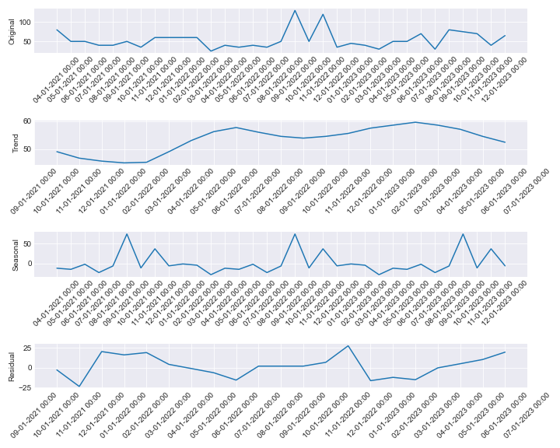

# Stationary tests for KIT0000897

ADF Test - p-value: 9.967147187920143e-06

ADF Test: Series is stationary

KPSS Test - p-value: 0.1

KPSS Test: Series is stationary

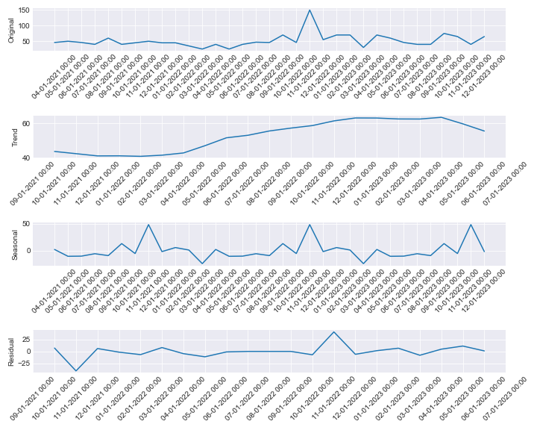

# Stationary tests for KIT0000642

ADF Test - p-value: 2.3709368374669157e-05

ADF Test: Series is stationary

KPSS Test - p-value: 0.1

KPSS Test: Series is stationary

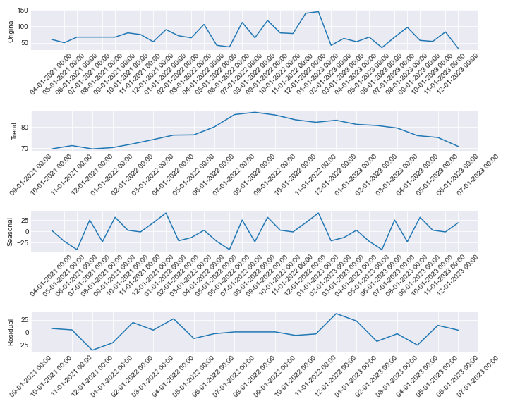

# Stationary tests for KIT0000645

ADF Test - p-value: 0.13704322198418034

ADF Test: Series is not stationary

KPSS Test - p-value: 0.1

KPSS Test: Series is stationary

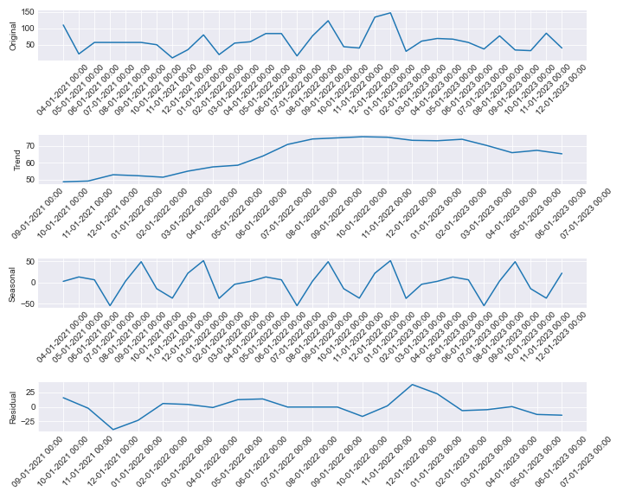

# Stationary tests for KIT0000647

ADF Test - p-value: 4.6490856944104914e-05

ADF Test: Series is stationary

KPSS Test - p-value: 0.1

KPSS Test: Series is stationary

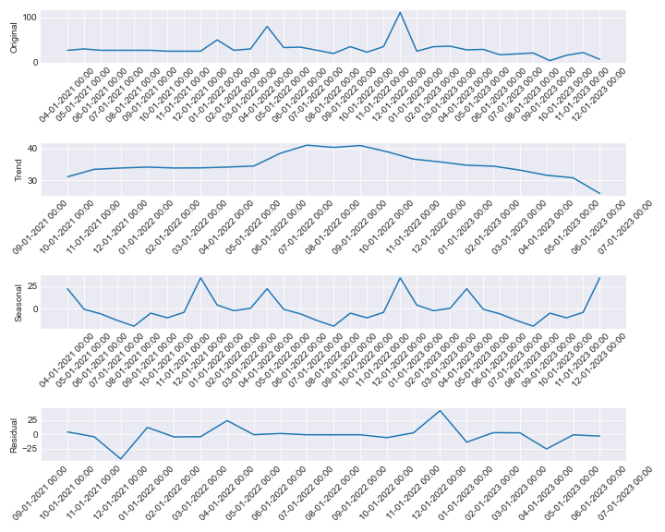

# Stationary tests for KIT0000737

ADF Test - p-value: 0.0008779145352028891

ADF Test: Series is stationary

KPSS Test - p-value: 0.1

KPSS Test: Series is stationary

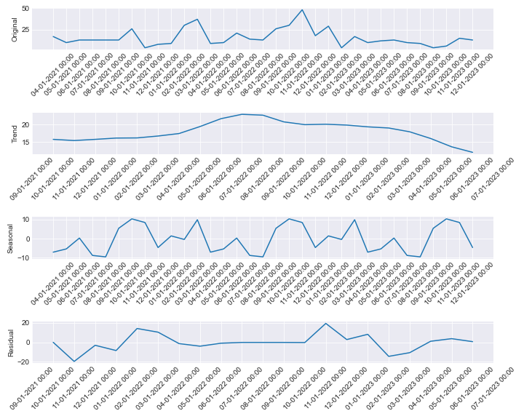

# Stationary tests for KIT0000285

ADF Test - p-value: 0.3004601081318611

ADF Test: Series is not stationary

KPSS Test - p-value: 0.06937551504746814

KPSS Test: Series is stationary

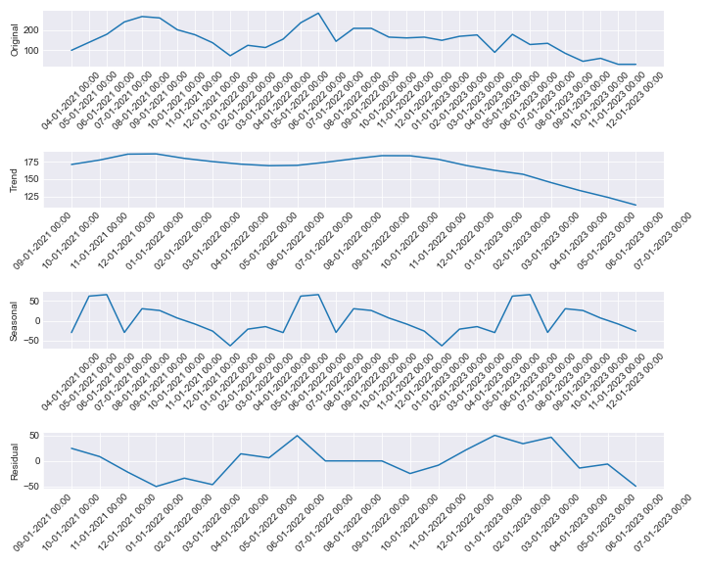

# Stationary tests for KIT0000286

ADF Test - p-value: 0.039498022129314914

ADF Test: Series is stationary

KPSS Test - p-value: 0.1

KPSS Test: Series is stationary

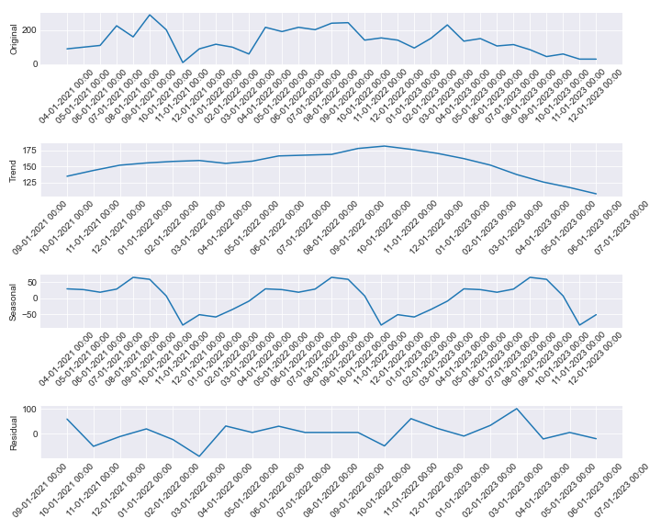

# Stationary tests for KIT0000949

ADF Test - p-value: 0.0008905716344006475

ADF Test: Series is stationary

KPSS Test - p-value: 0.1

KPSS Test: Series is stationary

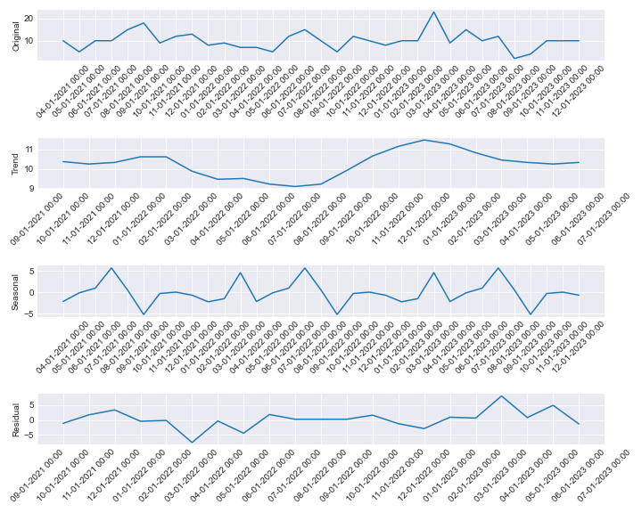

# Stationary tests for KIT0000937

ADF Test - p-value: 4.510649819277309e-07

ADF Test: Series is stationary

KPSS Test - p-value: 0.1

KPSS Test: Series is stationary

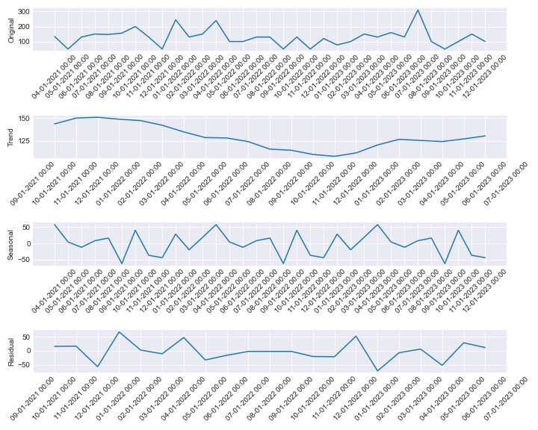

# Stationary tests for KIT0000938

ADF Test - p-value: 2.9819271399452393e-07

ADF Test: Series is stationary

KPSS Test - p-value: 0.058744212427964744

KPSS Test: Series is stationary

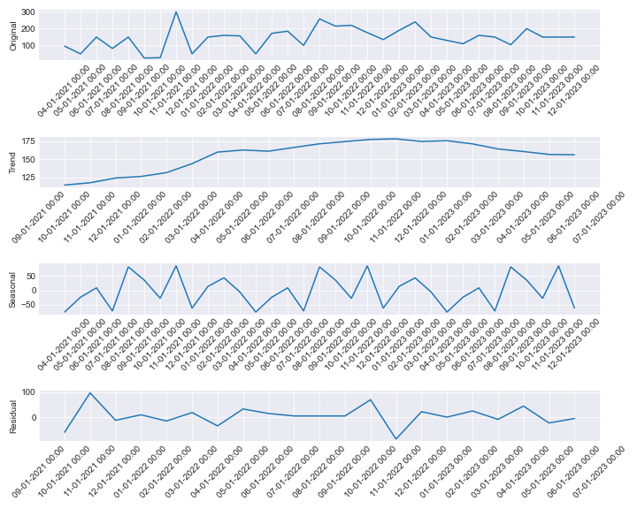

# Stationary tests for KIT0000894

ADF Test - p-value: 6.669157341082252e-05

ADF Test: Series is stationary

KPSS Test - p-value: 0.1

KPSS Test: Series is stationary

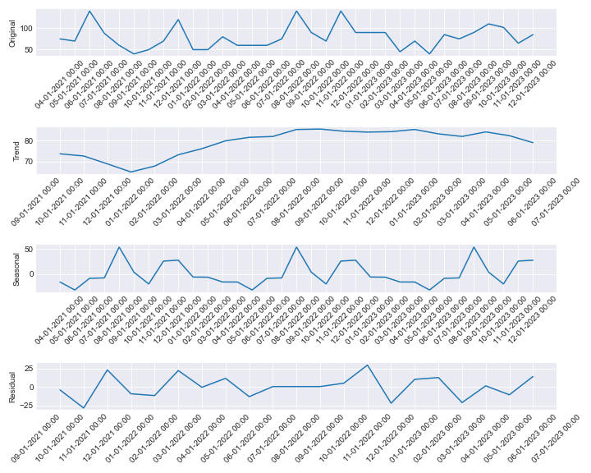

# Stationary tests for KIT0000895

ADF Test - p-value: 0.04756245857658564

ADF Test: Series is stationary

KPSS Test - p-value: 0.1

KPSS Test: Series is stationary

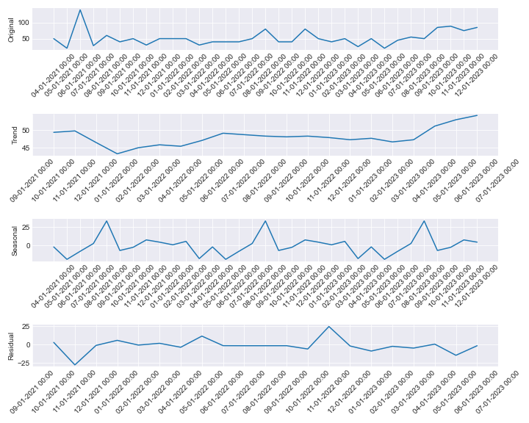

# Stationary tests for KIT0000219

ADF Test - p-value: 0.0006649330762183261

ADF Test: Series is stationary

KPSS Test - p-value: 0.1

KPSS Test: Series is stationary

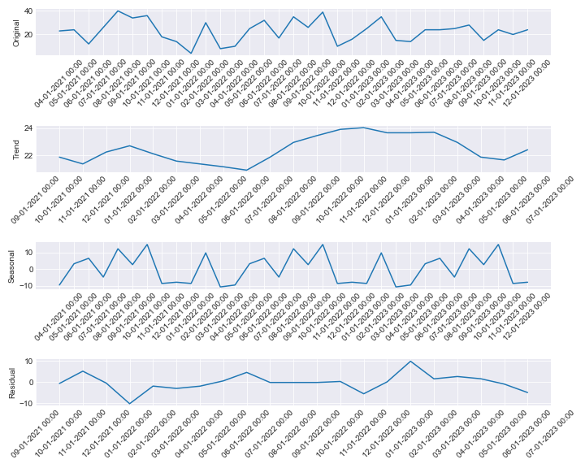

# Stationary tests for KIT0000933

ADF Test - p-value: 5.358783334175321e-07

ADF Test: Series is stationary

KPSS Test - p-value: 0.1

KPSS Test: Series is stationary

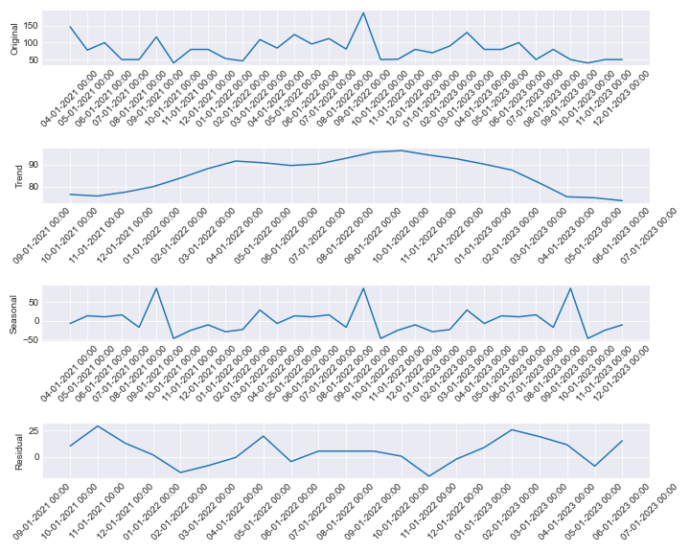

# Stationary tests for KIT0000627

ADF Test - p-value: 5.629782592064588e-07

ADF Test: Series is stationary

KPSS Test - p-value: 0.1

KPSS Test: Series is stationary

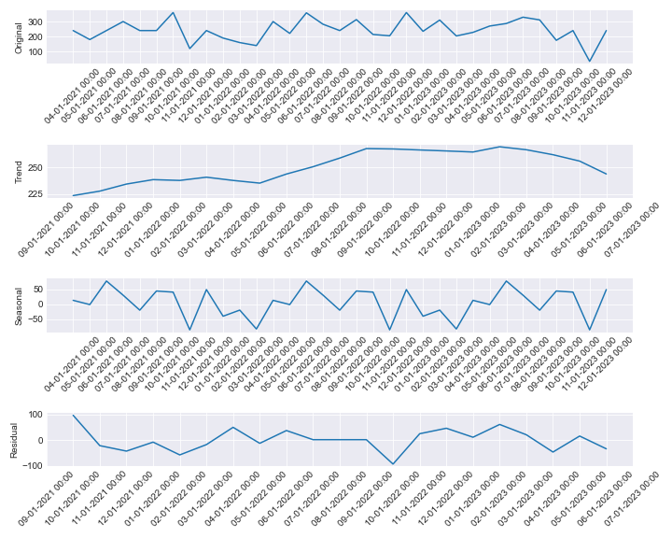

# Stationary tests for KIT0000581

ADF Test - p-value: 0.00040232277360016704

ADF Test: Series is stationary

KPSS Test - p-value: 0.1

KPSS Test: Series is stationary

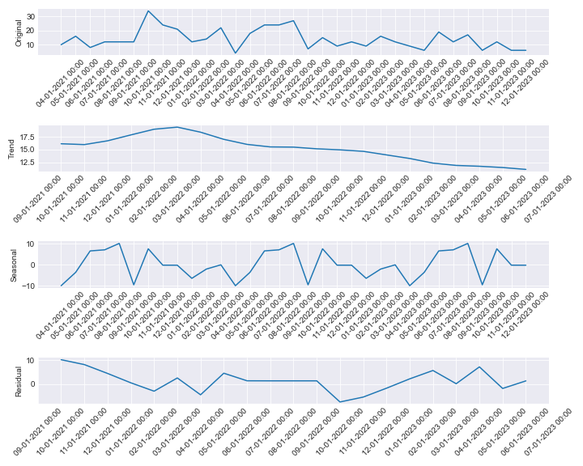

# Stationary tests for KIT0000928

ADF Test - p-value: 0.6115497553928639

ADF Test: Series is not stationary

KPSS Test - p-value: 0.02495645154844221

KPSS Test: Series is not stationary

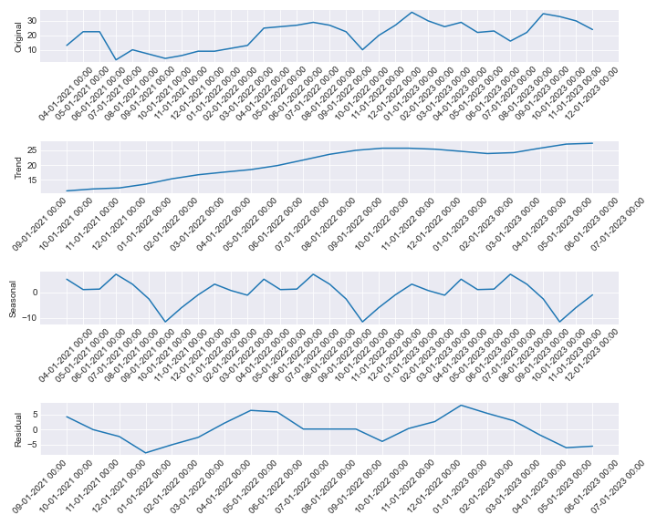

# Stationary tests for KIT0000365

ADF Test - p-value: 0.7104080078366097

ADF Test: Series is not stationary

KPSS Test - p-value: 0.09248949720707404

KPSS Test: Series is stationary

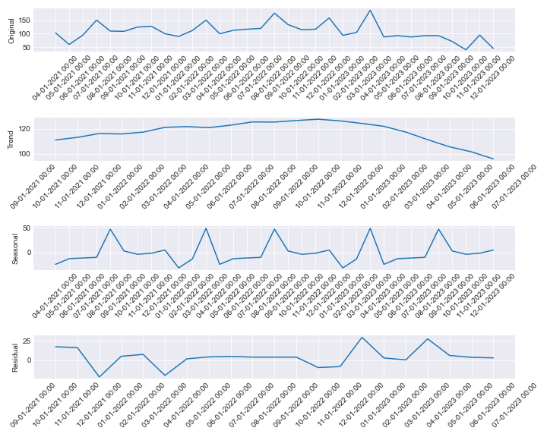

# Stationary tests for KIT0000366

ADF Test - p-value: 0.7576656476678534

ADF Test: Series is not stationary

KPSS Test - p-value: 0.0938359666343283

KPSS Test: Series is stationary

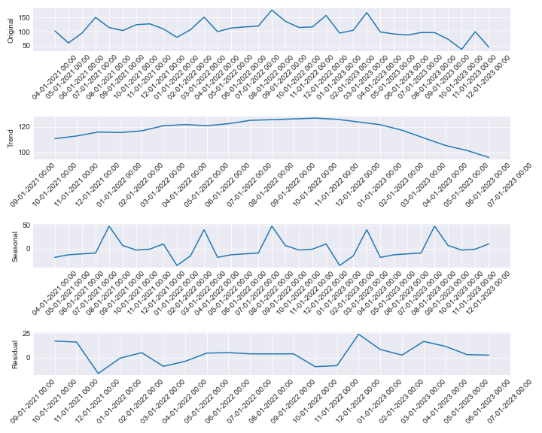

# Stationary tests for KIT0001042

ADF Test - p-value: 0.24005152560855292

ADF Test: Series is not stationary

KPSS Test - p-value: 0.09730441903139

KPSS Test: Series is stationary

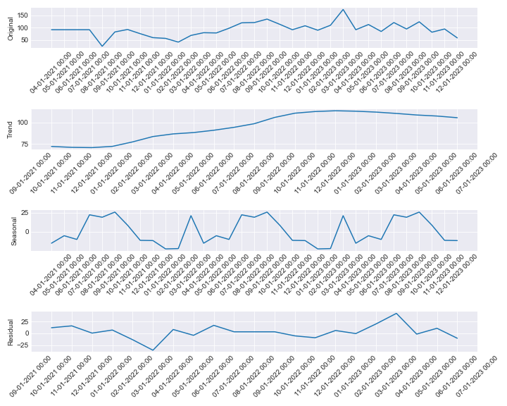

# Stationary tests for KIT0000370

ADF Test - p-value: 0.0003218145769282889

ADF Test: Series is stationary

KPSS Test - p-value: 0.1

KPSS Test: Series is stationary

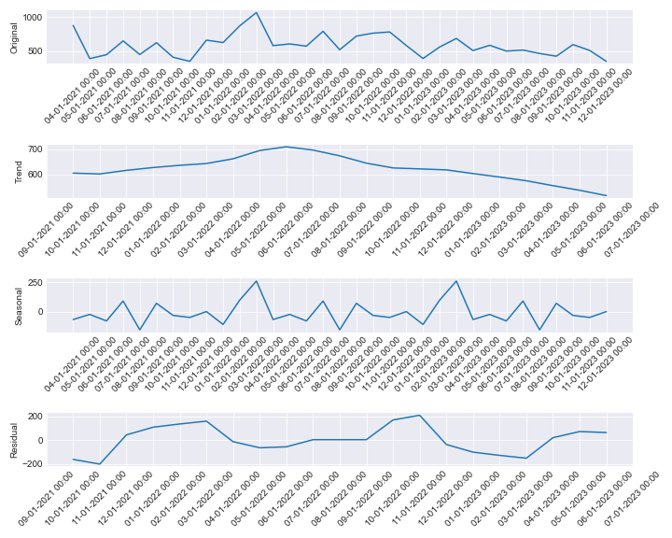

# Stationary tests for KIT0000445

ADF Test - p-value: 0.4092534881979199

ADF Test: Series is not stationary

KPSS Test - p-value: 0.1

KPSS Test: Series is stationary

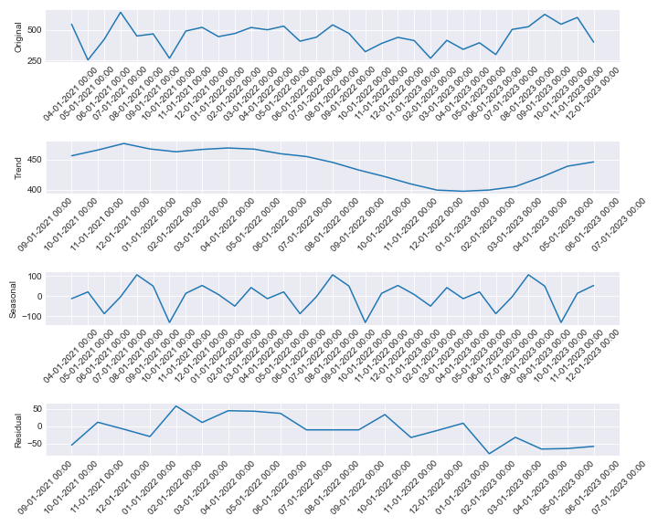

# Stationary tests for KIT0000609

ADF Test - p-value: 0.7876717843841361

ADF Test: Series is not stationary

KPSS Test - p-value: 0.01607262389465568

KPSS Test: Series is not stationary

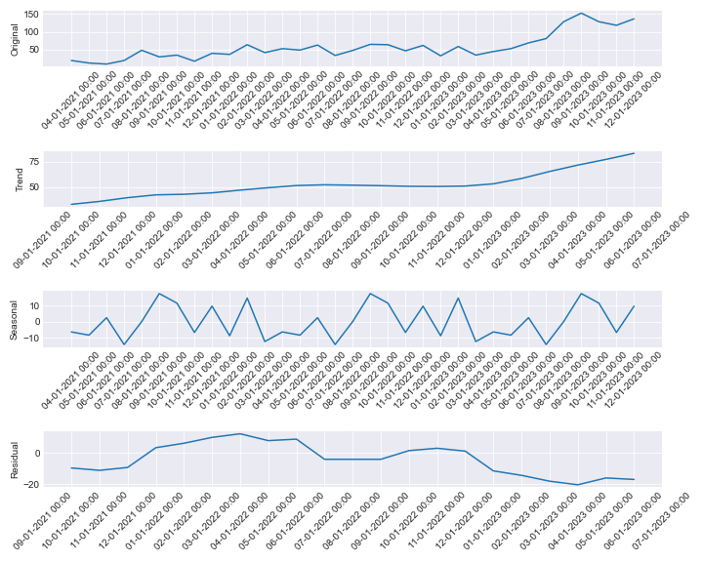

# Stationary tests for KIT0000905

ADF Test - p-value: 0.011139811019490312

ADF Test: Series is stationary

KPSS Test - p-value: 0.04672969243193214

KPSS Test: Series is not stationary

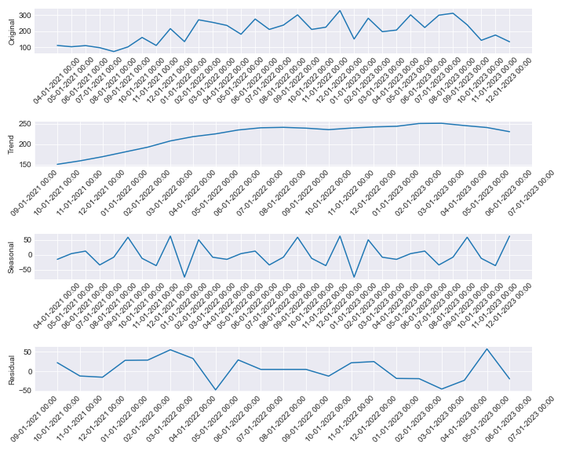

# Stationary tests for KIT0000968

ADF Test - p-value: 0.10642728257495271

ADF Test: Series is not stationary

KPSS Test - p-value: 0.029926060766016914

KPSS Test: Series is not stationary

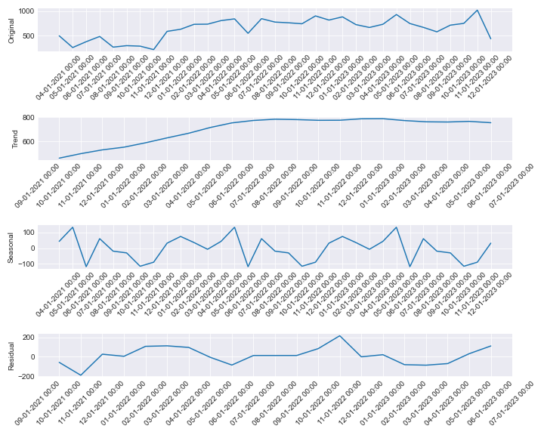

# Stationary tests for KIT0000468

ADF Test - p-value: 0.8283762069835718

ADF Test: Series is not stationary

KPSS Test - p-value: 0.011734460284513356

KPSS Test: Series is not stationary

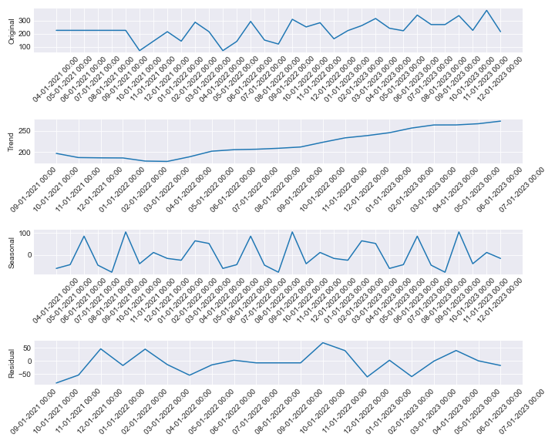

# Stationary tests for KIT0000524

ADF Test - p-value: 0.0003010637096204278

ADF Test: Series is stationary

KPSS Test - p-value: 0.1

KPSS Test: Series is stationary

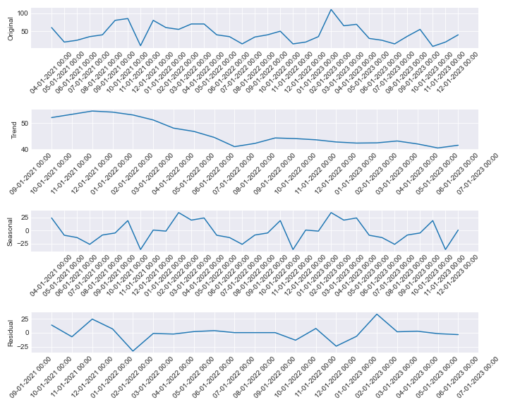

# Stationary tests for KIT0000563

ADF Test - p-value: 0.8182718182070847

ADF Test: Series is not stationary

KPSS Test - p-value: 0.014041425951214796

KPSS Test: Series is not stationary

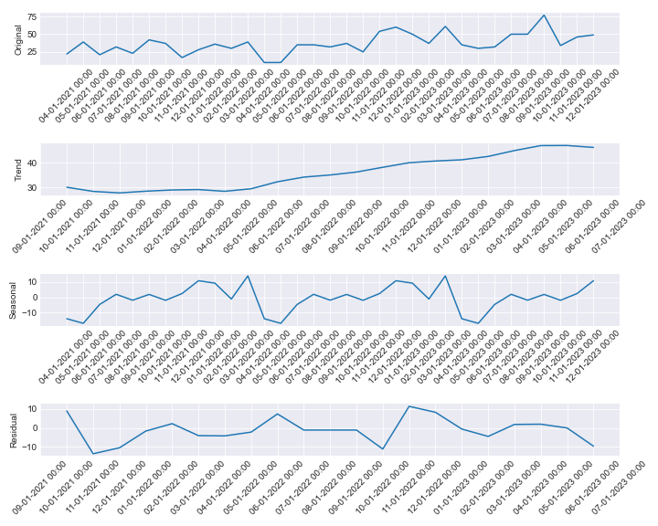

# Stationary tests for KIT0000564

ADF Test - p-value: 0.0004948268459414033

ADF Test: Series is stationary

KPSS Test - p-value: 0.1

KPSS Test: Series is stationary

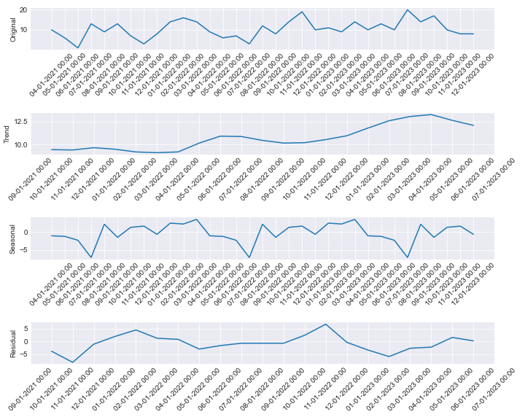

# Stationary tests for KIT0000565

ADF Test - p-value: 7.193008923843535e-14

ADF Test: Series is stationary

KPSS Test - p-value: 0.0862235696833787

KPSS Test: Series is stationary

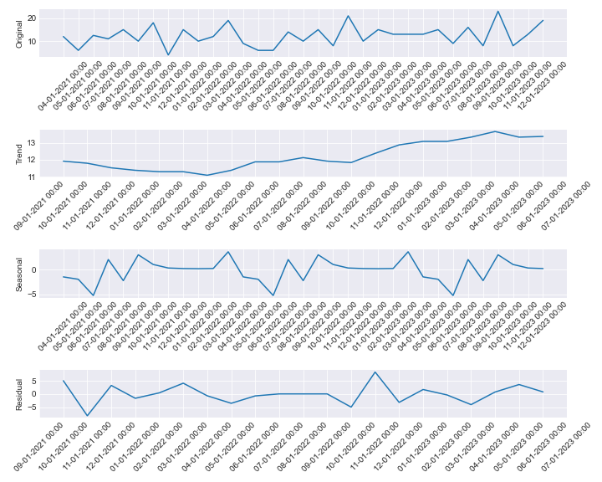

# Stationary tests for KIT0000569

ADF Test - p-value: 1.3319636980448474e-08

ADF Test: Series is stationary

KPSS Test - p-value: 0.1

KPSS Test: Series is stationary

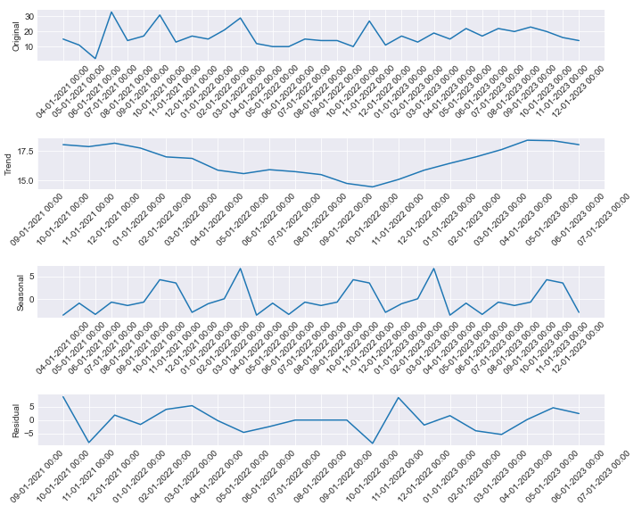

# Stationary tests for KIT0000994

ADF Test - p-value: 0.16182814240045396

ADF Test: Series is not stationary

KPSS Test - p-value: 0.1

KPSS Test: Series is stationary

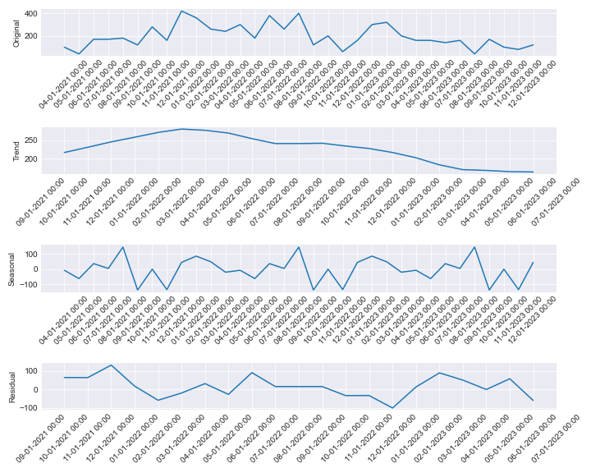

# Stationary tests for KIT0000995

ADF Test - p-value: 0.18557469781794683

ADF Test: Series is not stationary

KPSS Test - p-value: 0.020529709866080333

KPSS Test: Series is not stationary

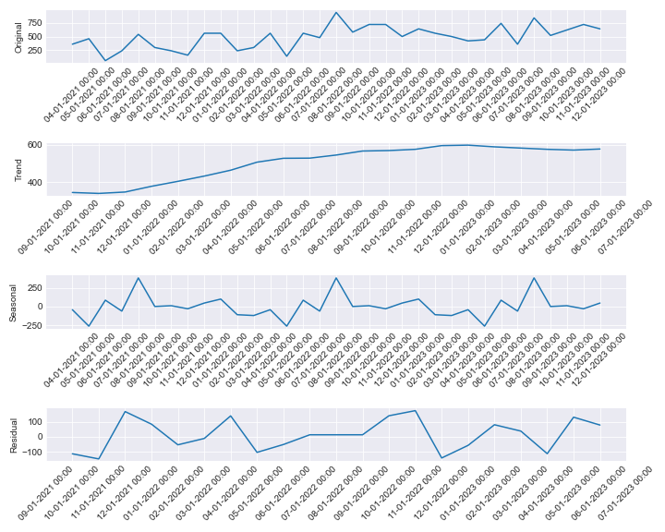

# Stationary tests for KIT0000975

ADF Test - p-value: 0.3556499611414623

ADF Test: Series is not stationary

KPSS Test - p-value: 0.1

KPSS Test: Series is stationary

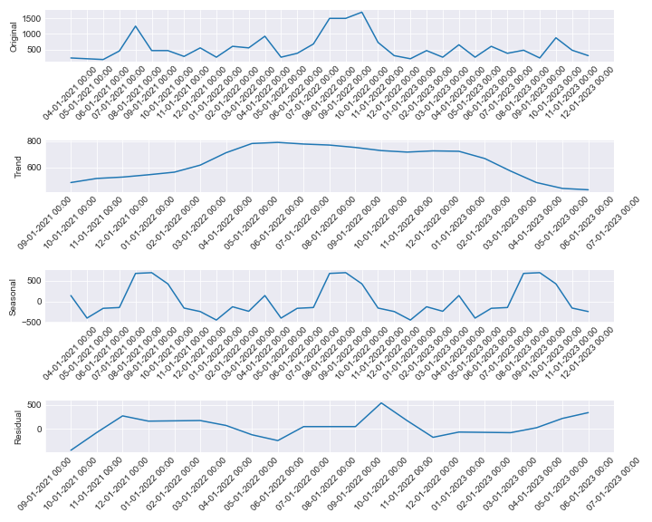

# Stationary tests for KIT0000976

ADF Test - p-value: 0.00018819136503996713

ADF Test: Series is stationary

KPSS Test - p-value: 0.1

KPSS Test: Series is stationary

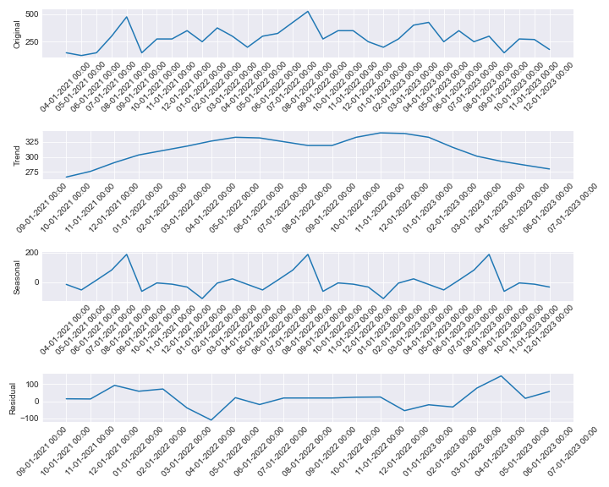

# Stationary tests for KIT0000978

ADF Test - p-value: 0.23799952631467447

ADF Test: Series is not stationary

KPSS Test - p-value: 0.1

KPSS Test: Series is stationary

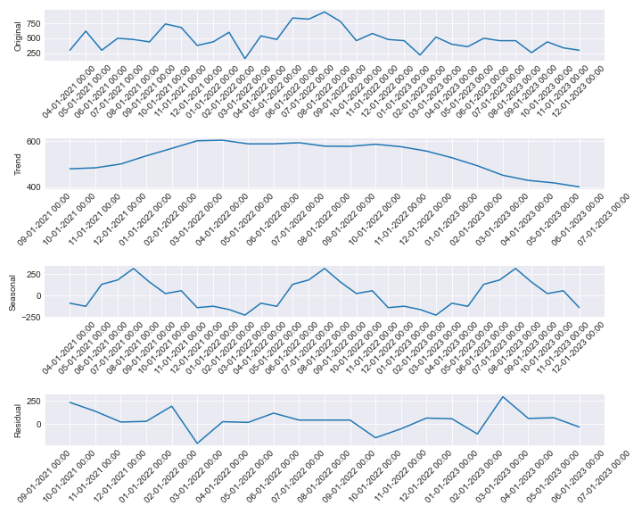

# Stationary tests for KIT0001031

ADF Test - p-value: 0.0001300227871842682

ADF Test: Series is stationary

KPSS Test - p-value: 0.1

KPSS Test: Series is stationary

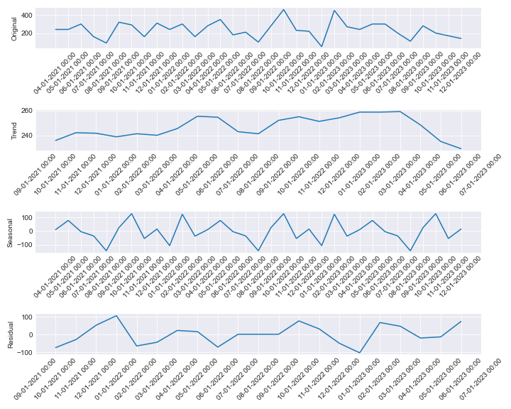

# Stationary tests for KIT0000417

ADF Test - p-value: 0.003992555911679827

ADF Test: Series is stationary

KPSS Test - p-value: 0.01992955559756167

KPSS Test: Series is not stationary

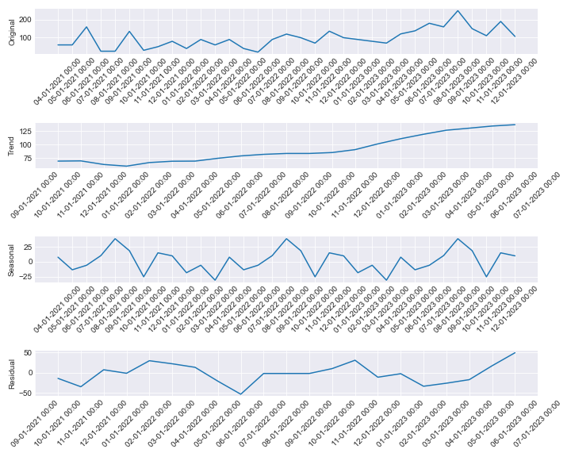

# Stationary tests for KIT0000143

ADF Test - p-value: 0.8276076976098617

ADF Test: Series is not stationary

KPSS Test - p-value: 0.01

KPSS Test: Series is not stationary

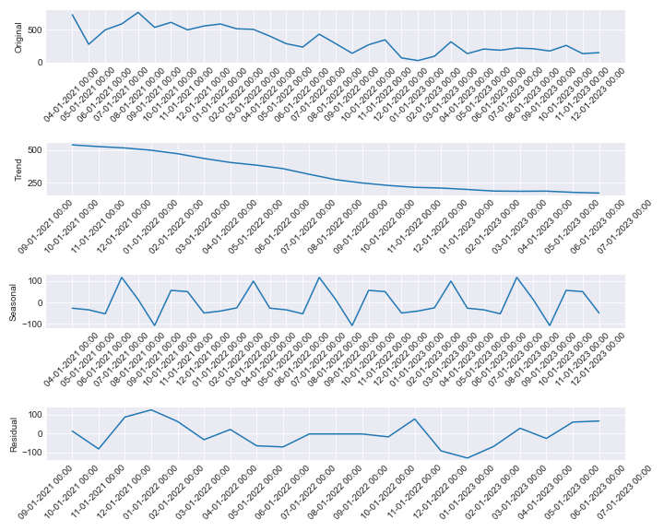

# Stationary tests for KIT0000144

ADF Test - p-value: 0.012619451592850063

ADF Test: Series is stationary

KPSS Test - p-value: 0.0148112434444434

KPSS Test: Series is not stationary

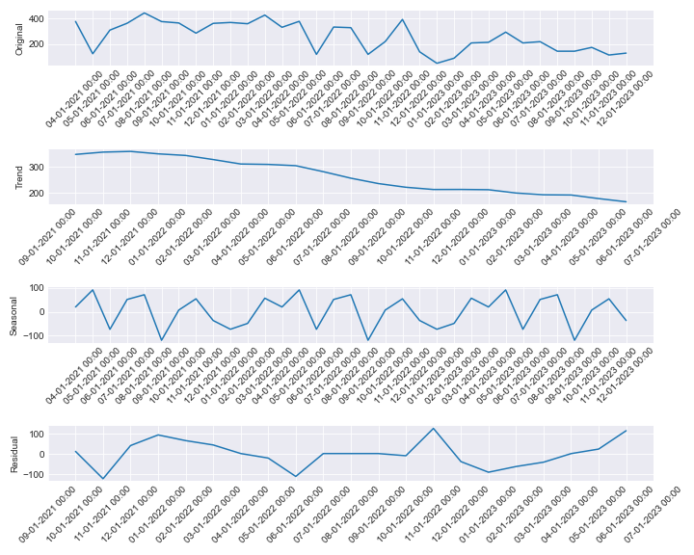

# Stationary tests for KIT0000145

ADF Test - p-value: 0.021498612506244307

ADF Test: Series is stationary

KPSS Test - p-value: 0.08632488488949303

KPSS Test: Series is stationary

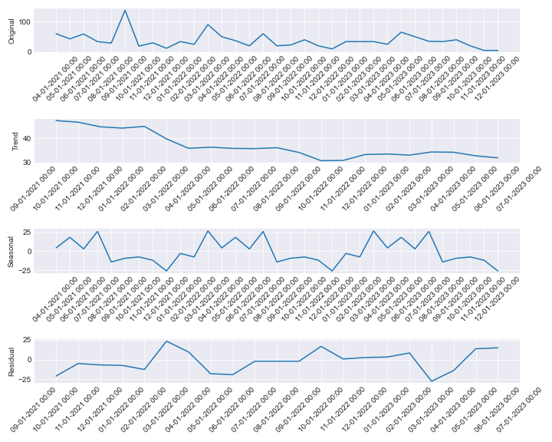

# Stationary tests for KIT0000146

ADF Test - p-value: 0.5884941150794901

ADF Test: Series is not stationary

KPSS Test - p-value: 0.018889773102496187

KPSS Test: Series is not stationary

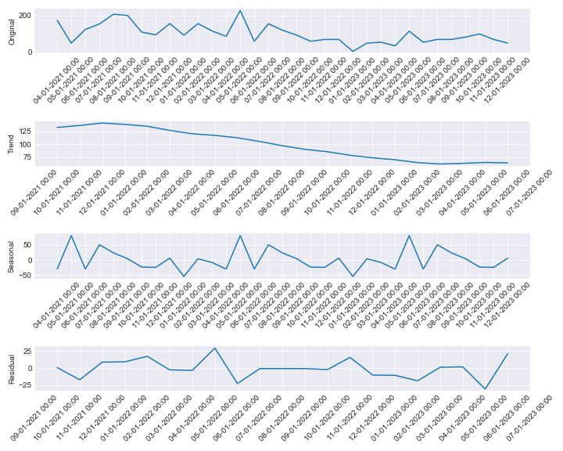

# Stationary tests for KIT0000660

ADF Test - p-value: 0.08315225264902415

ADF Test: Series is not stationary

KPSS Test - p-value: 0.1

KPSS Test: Series is stationary

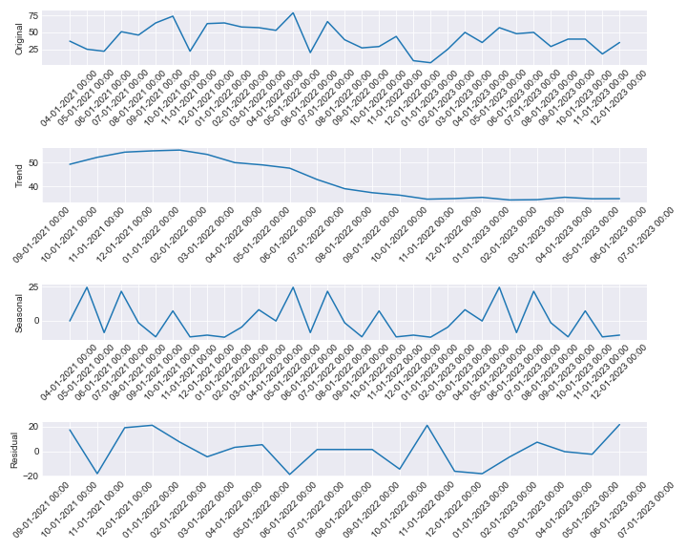

# Stationary tests for KIT0000868

ADF Test - p-value: 0.0551386018623677

ADF Test: Series is not stationary

KPSS Test - p-value: 0.1

KPSS Test: Series is stationary

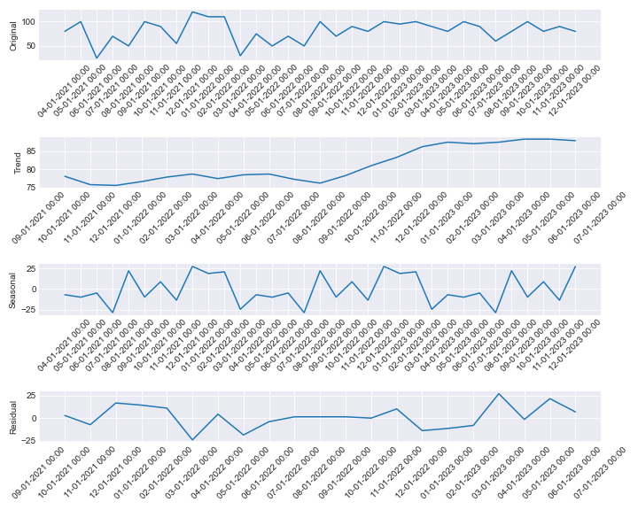

# Stationary tests for KIT0000519

ADF Test - p-value: 0.02547731083707559

ADF Test: Series is stationary

KPSS Test - p-value: 0.01

KPSS Test: Series is not stationary

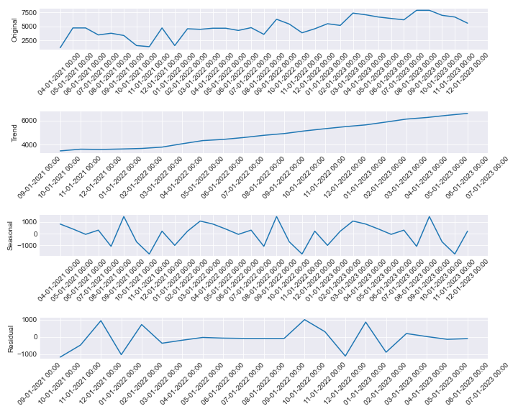

# Stationary tests for KIT0001030

ADF Test - p-value: 2.7076397851637512e-05

ADF Test: Series is stationary

KPSS Test - p-value: 0.06354592445017458

KPSS Test: Series is stationary

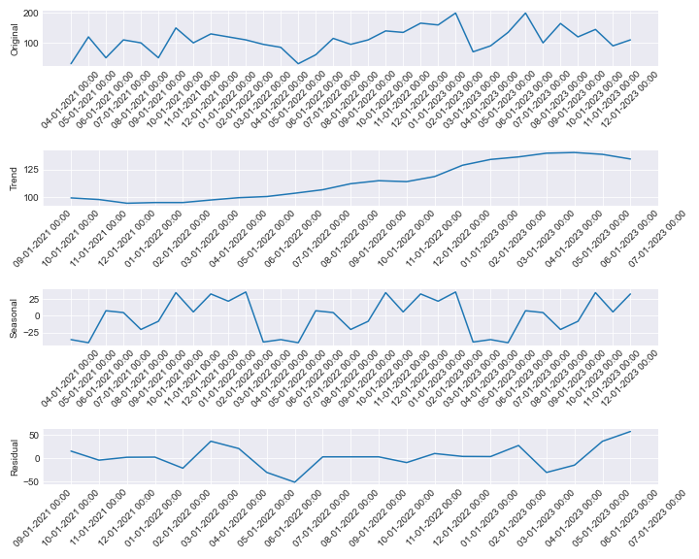

# Stationary tests for KIT0000803

ADF Test - p-value: 0.015379106645844156

ADF Test: Series is stationary

KPSS Test - p-value: 0.1

KPSS Test: Series is stationary

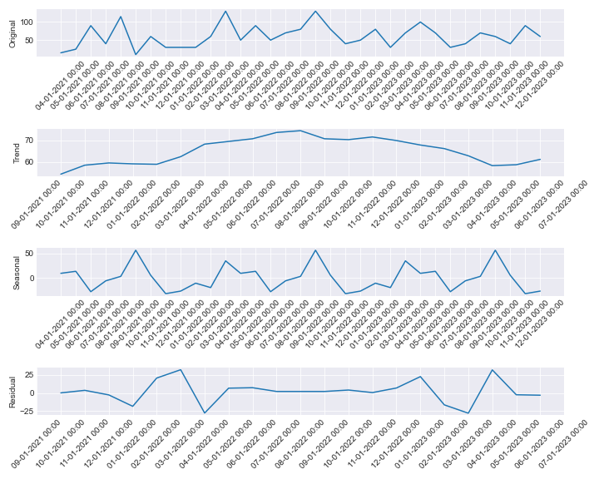

# Stationary tests for KIT0000854

ADF Test - p-value: 0.0001982823247169729

ADF Test: Series is stationary

KPSS Test - p-value: 0.1

KPSS Test: Series is stationary

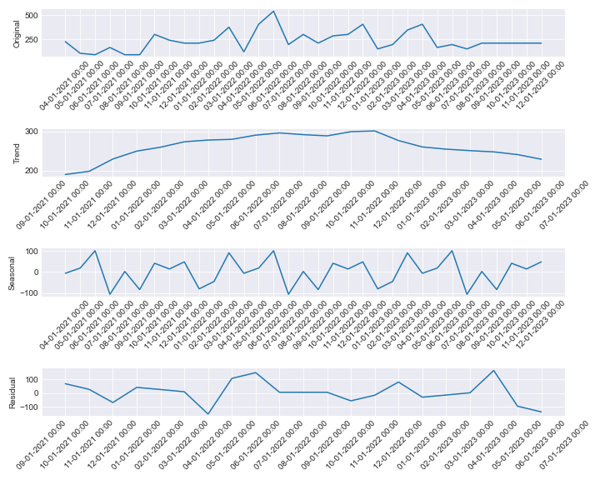

# Stationary tests for KIT0001014

ADF Test - p-value: 0.5971984913325046

ADF Test: Series is not stationary

KPSS Test - p-value: 0.1

KPSS Test: Series is stationary

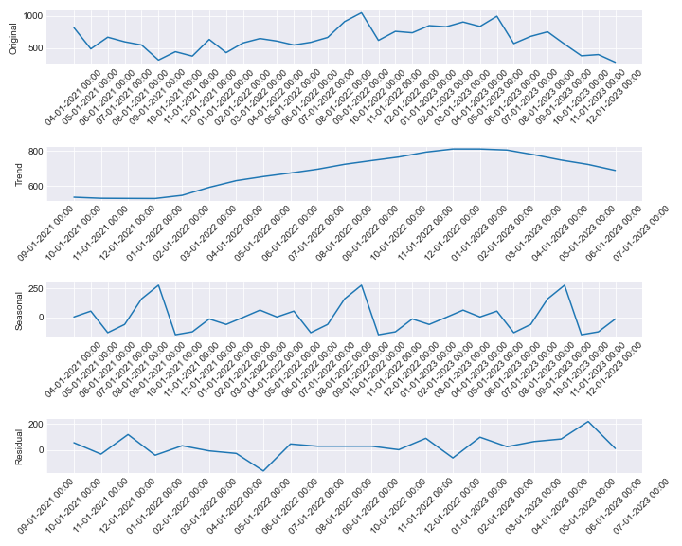

# Stationary tests for KIT0000467

ADF Test - p-value: 0.6741540754554898

ADF Test: Series is not stationary

KPSS Test - p-value: 0.01984547200822035

KPSS Test: Series is not stationary

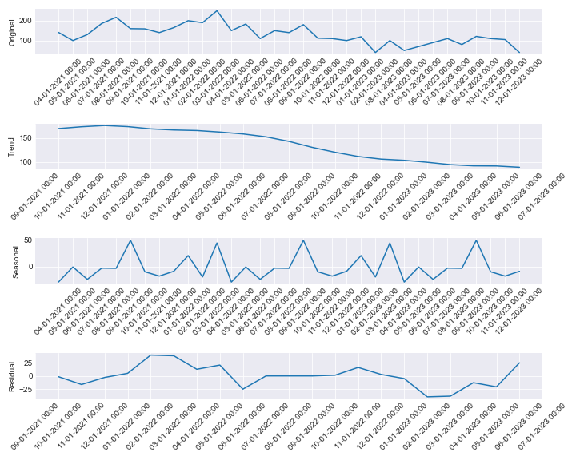

# Stationary tests for KIT0000696

ADF Test - p-value: 3.4896894483534354e-08

ADF Test: Series is stationary

KPSS Test - p-value: 0.1

KPSS Test: Series is stationary

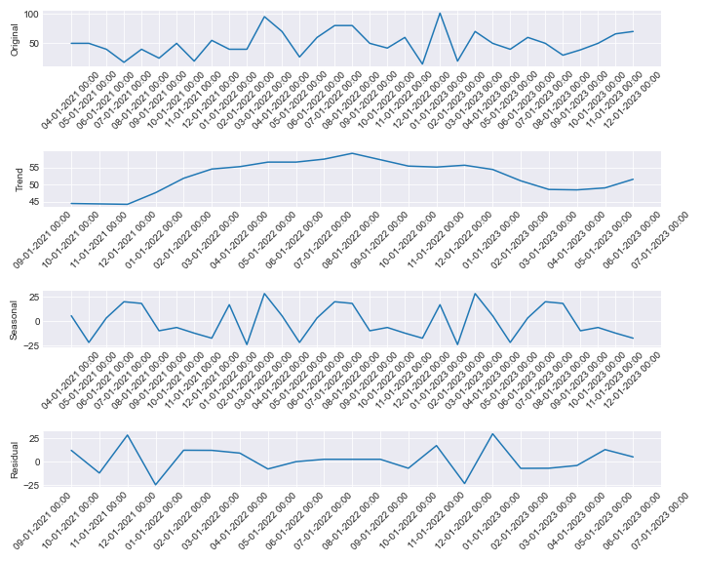

# Stationary tests for KIT0000170

ADF Test - p-value: 0.06599687915399026

ADF Test: Series is not stationary

KPSS Test - p-value: 0.03631165300194206

KPSS Test: Series is not stationary

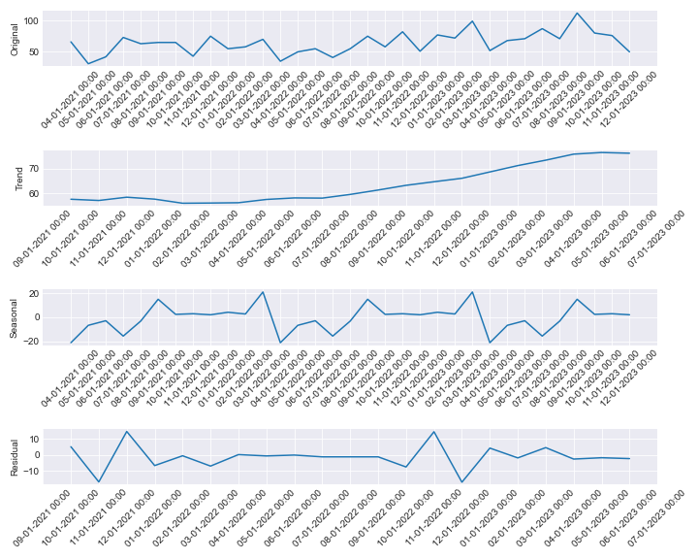

# Stationary tests for KIT0001027

ADF Test - p-value: 0.0011644136763320897

ADF Test: Series is stationary

KPSS Test - p-value: 0.01651333584222071

KPSS Test: Series is not stationary

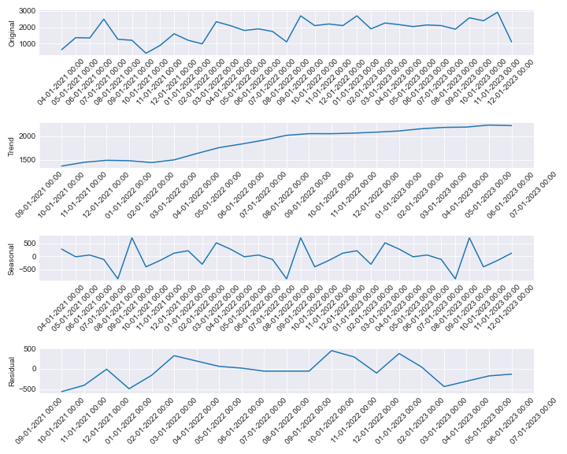

# Stationary tests for KIT0001028

ADF Test - p-value: 0.0002704536196382731

ADF Test: Series is stationary

KPSS Test - p-value: 0.018884714805264456

KPSS Test: Series is not stationary

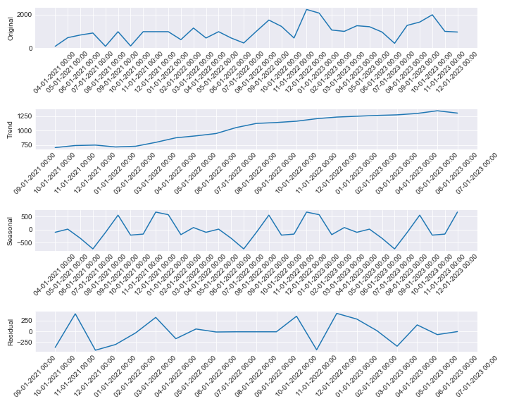

# Stationary tests for KIT0000432

ADF Test - p-value: 0.11755574501378496

ADF Test: Series is not stationary

KPSS Test - p-value: 0.08058766523470301

KPSS Test: Series is stationary

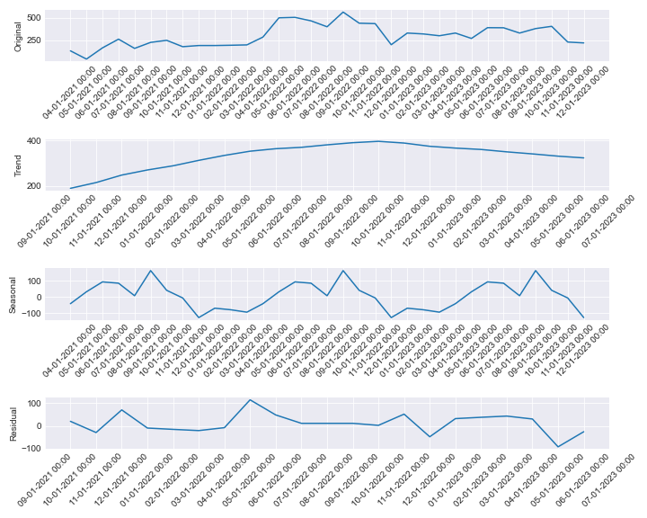

# Stationary tests for KIT0000860

ADF Test - p-value: 0.5857843268969505

ADF Test: Series is not stationary

KPSS Test - p-value: 0.01558911895697922

KPSS Test: Series is not stationary

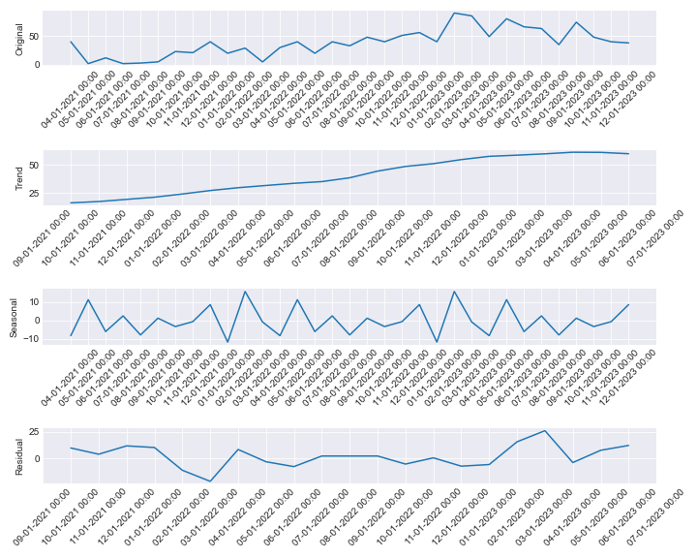

# Stationary tests for KIT0000008

ADF Test - p-value: 0.010678957588987053

ADF Test: Series is stationary

KPSS Test - p-value: 0.1

KPSS Test: Series is stationary

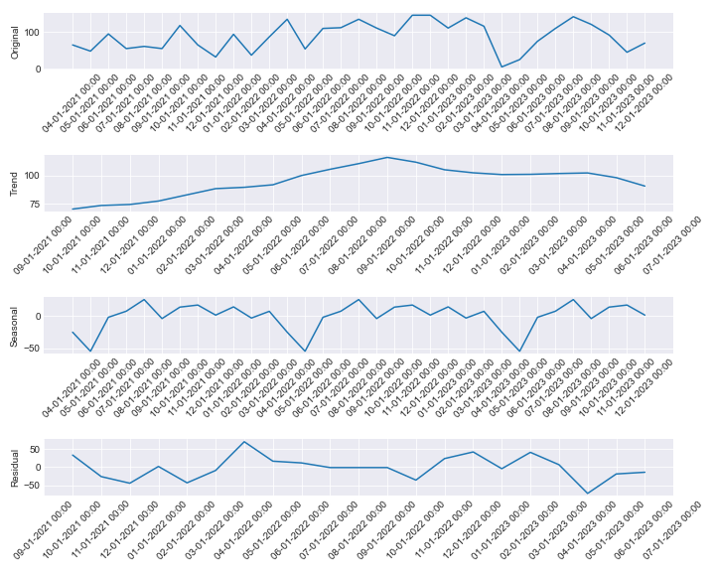

# Stationary tests for KIT0000010

ADF Test - p-value: 0.004016116859862131

ADF Test: Series is stationary

KPSS Test - p-value: 0.1

KPSS Test: Series is stationary

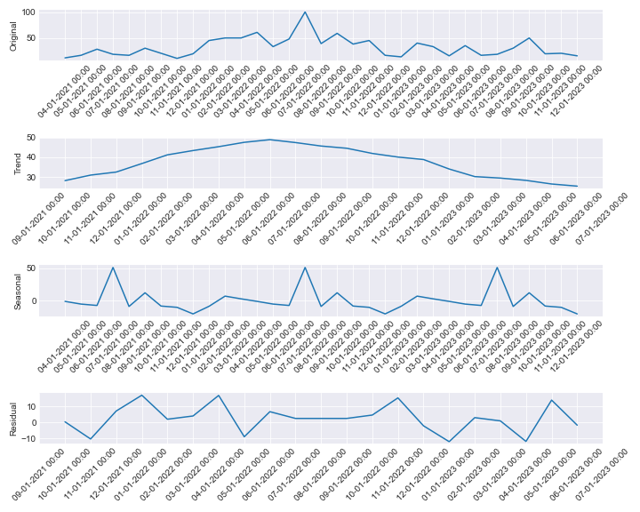

# Stationary tests for KIT0000012

ADF Test - p-value: 0.0004568936569361419

ADF Test: Series is stationary

KPSS Test - p-value: 0.1

KPSS Test: Series is stationary

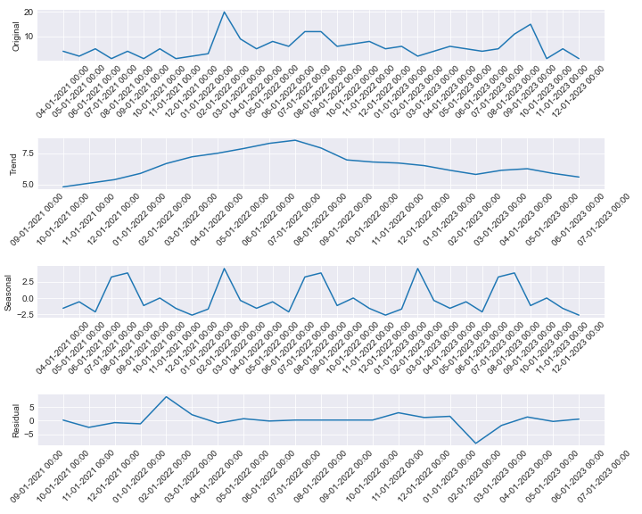

# Stationary tests for KIT0000013

ADF Test - p-value: 0.0117831613660384

ADF Test: Series is stationary

KPSS Test - p-value: 0.1

KPSS Test: Series is stationary

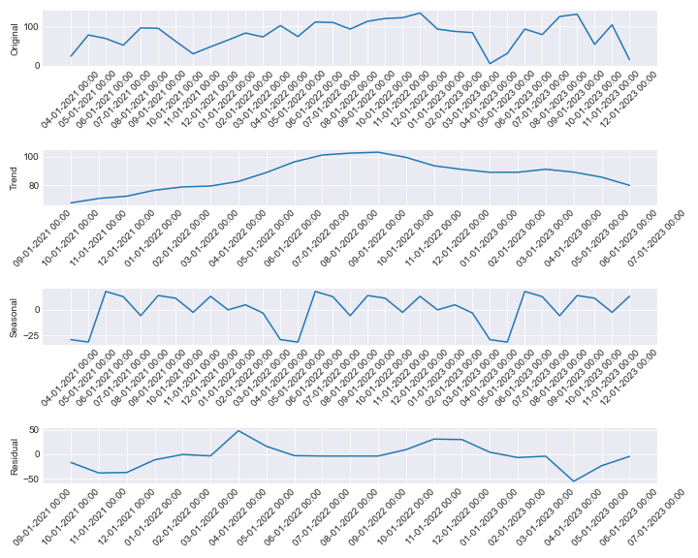

# Stationary tests for KIT0000194

ADF Test - p-value: 5.338080275822807e-06

ADF Test: Series is stationary

KPSS Test - p-value: 0.022606541568747984

KPSS Test: Series is not stationary

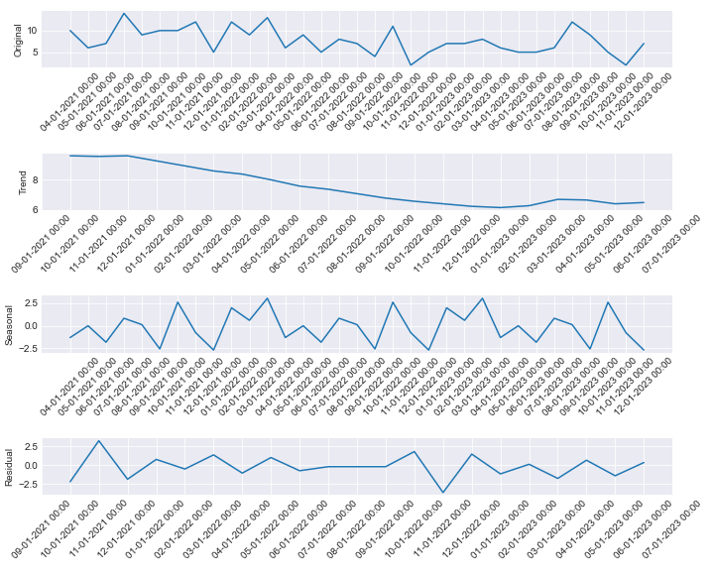

# Stationary tests for KIT0000195

ADF Test - p-value: 6.539080495213263e-06

ADF Test: Series is stationary

KPSS Test - p-value: 0.1

KPSS Test: Series is stationary

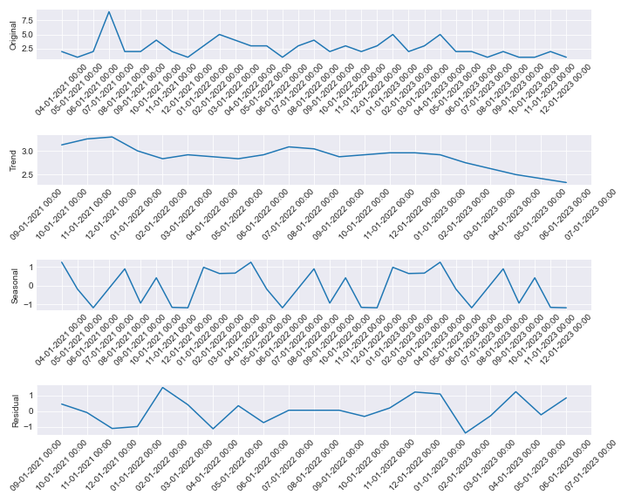

# Stationary tests for KIT0000948

ADF Test - p-value: 0.00027480718133655044

ADF Test: Series is stationary

KPSS Test - p-value: 0.041369581070466094

KPSS Test: Series is not stationary

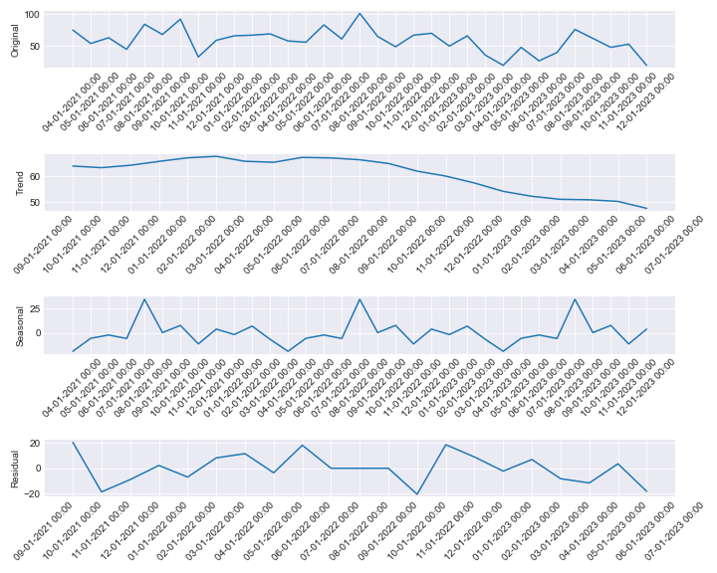

# Stationary tests for KIT0000953

ADF Test - p-value: 0.3325546344721403

ADF Test: Series is not stationary

KPSS Test - p-value: 0.1

KPSS Test: Series is stationary

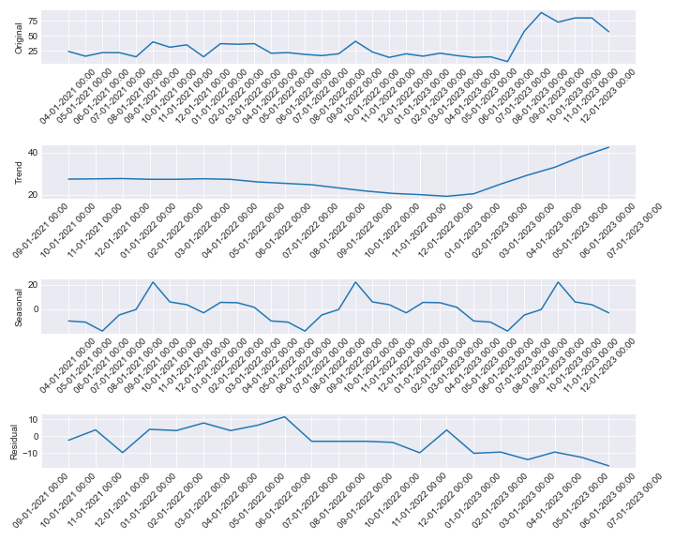

# Stationary tests for KIT0000958

ADF Test - p-value: 0.0008071286779764957

ADF Test: Series is stationary

KPSS Test - p-value: 0.07770209691077659

KPSS Test: Series is stationary

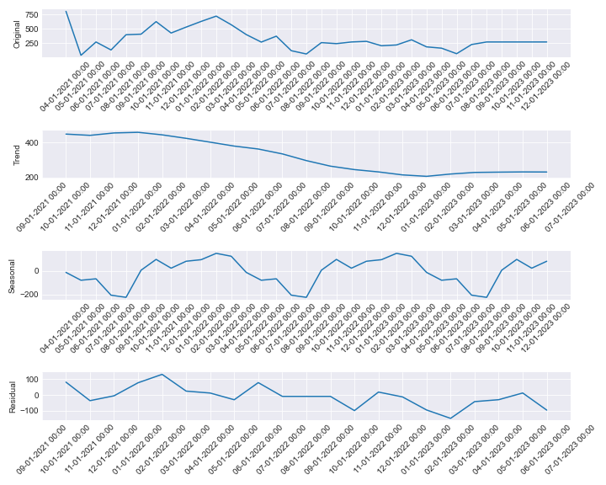

# Stationary tests for KIT0000985

ADF Test - p-value: 0.04314919876119619

ADF Test: Series is stationary

KPSS Test - p-value: 0.1

KPSS Test: Series is stationary

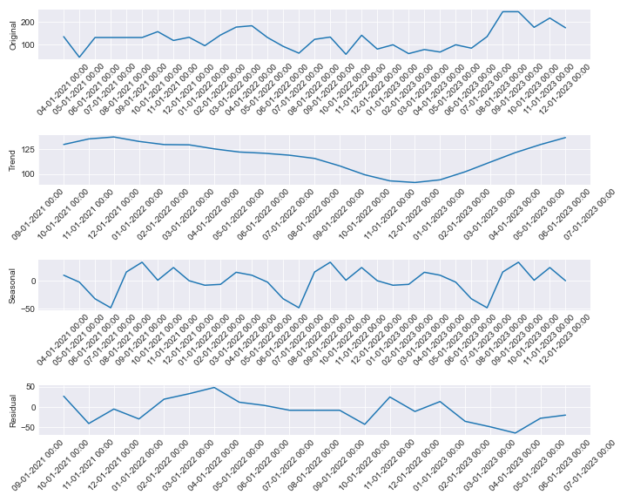

# Stationary tests for KIT0001013

ADF Test - p-value: 0.06664762581540198

ADF Test: Series is not stationary

KPSS Test - p-value: 0.09958057123896986

KPSS Test: Series is stationary

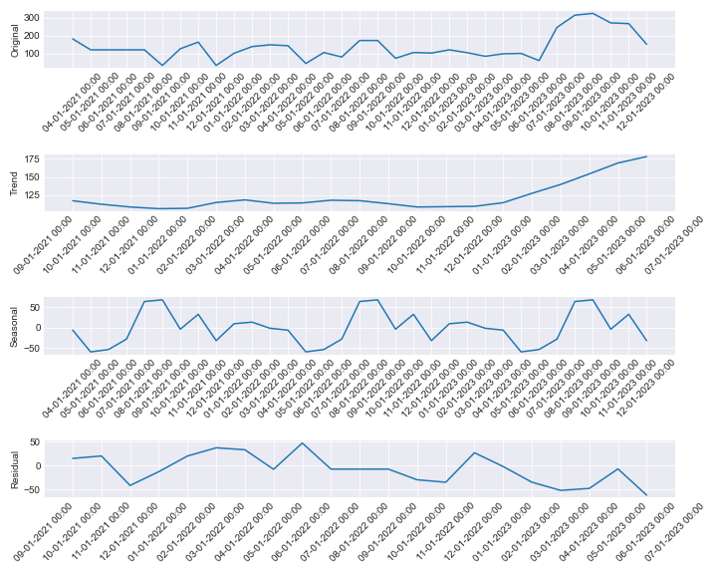

# Stationary tests for KIT0000582

ADF Test - p-value: 0.43300168687522195

ADF Test: Series is not stationary

KPSS Test - p-value: 0.1

KPSS Test: Series is stationary

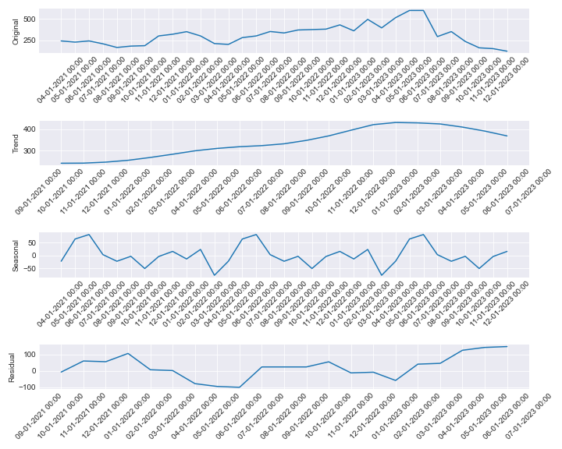

# Stationary tests for KIT0001024

ADF Test - p-value: 0.4890552070659719

ADF Test: Series is not stationary

KPSS Test - p-value: 0.04666142897470436

KPSS Test: Series is not stationary

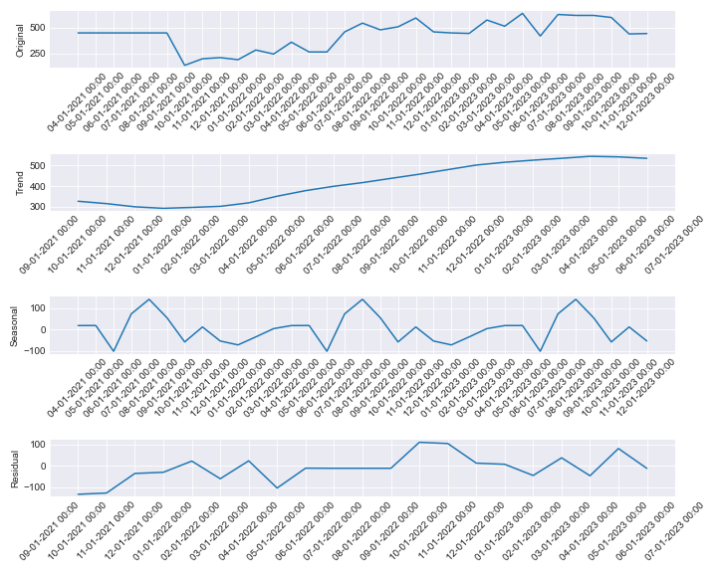

# Stationary tests for KIT0001017

ADF Test - p-value: 0.034164107553098635

ADF Test: Series is stationary

KPSS Test - p-value: 0.1

KPSS Test: Series is stationary

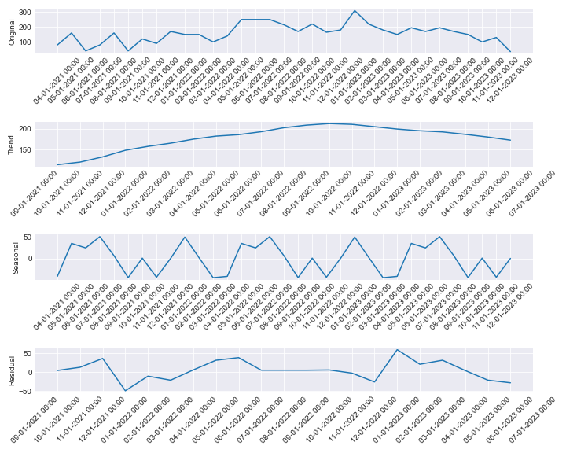

# Stationary tests for KIT0000437

ADF Test - p-value: 0.00011538357527102854

ADF Test: Series is stationary

KPSS Test - p-value: 0.06595510333582331

KPSS Test: Series is stationary

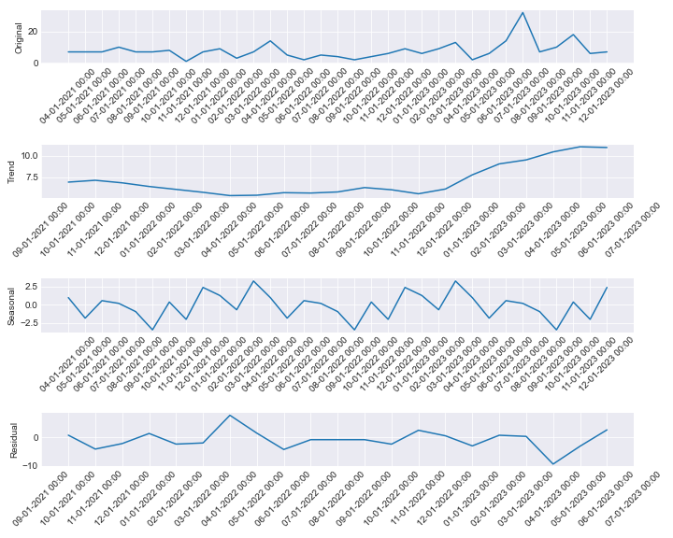

# Stationary tests for KIT0000296

ADF Test - p-value: 0.2588657098098063

ADF Test: Series is not stationary

KPSS Test - p-value: 0.09859386975374813

KPSS Test: Series is stationary

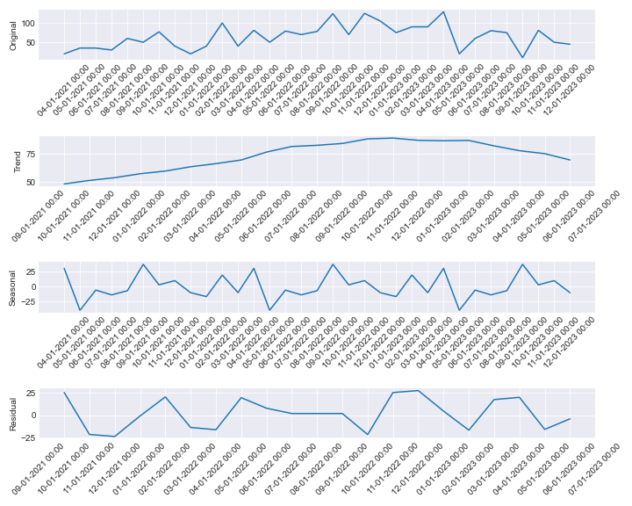

# Stationary tests for KIT0000297

ADF Test - p-value: 0.08821456973777397

ADF Test: Series is not stationary

KPSS Test - p-value: 0.1

KPSS Test: Series is stationary

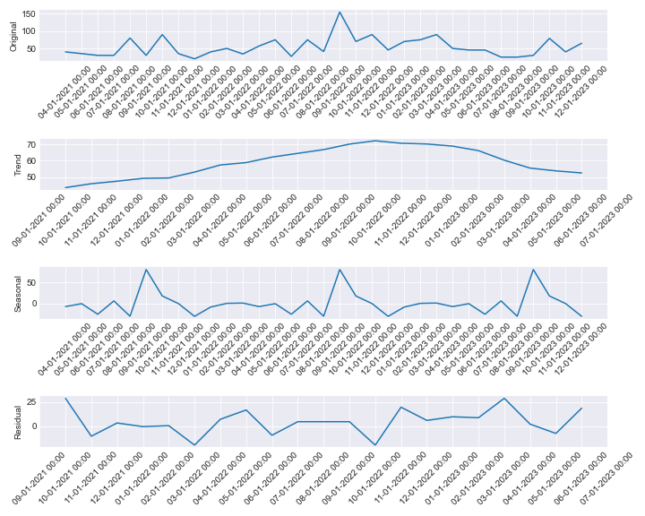

# Stationary tests for KIT0000355

ADF Test - p-value: 0.08091931829986232

ADF Test: Series is not stationary

KPSS Test - p-value: 0.1

KPSS Test: Series is stationary

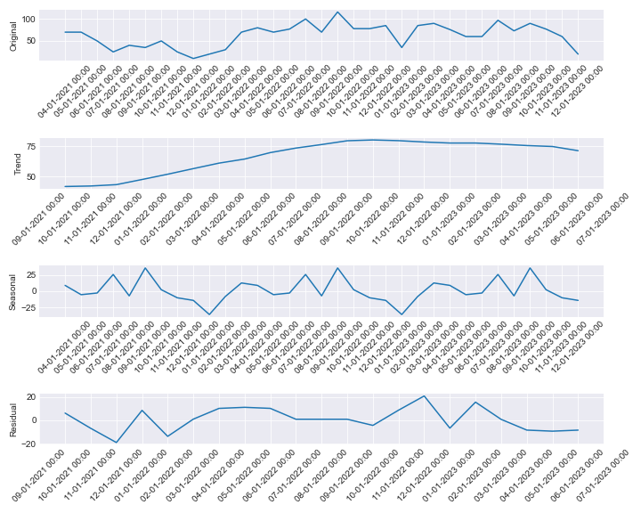

# Stationary tests for KIT0000674

ADF Test - p-value: 0.1376635559115989

ADF Test: Series is not stationary

KPSS Test - p-value: 0.07968020340557483

KPSS Test: Series is stationary

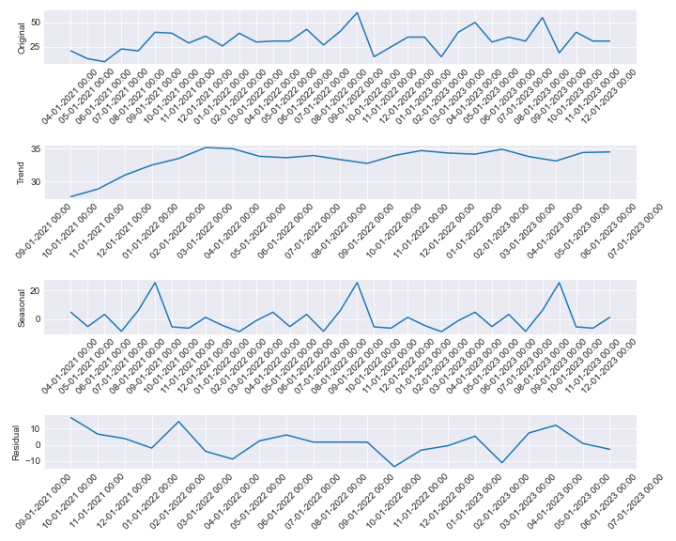

# Stationary tests for KIT0000503

ADF Test - p-value: 0.24950052782949522

ADF Test: Series is not stationary

KPSS Test - p-value: 0.1

KPSS Test: Series is stationary

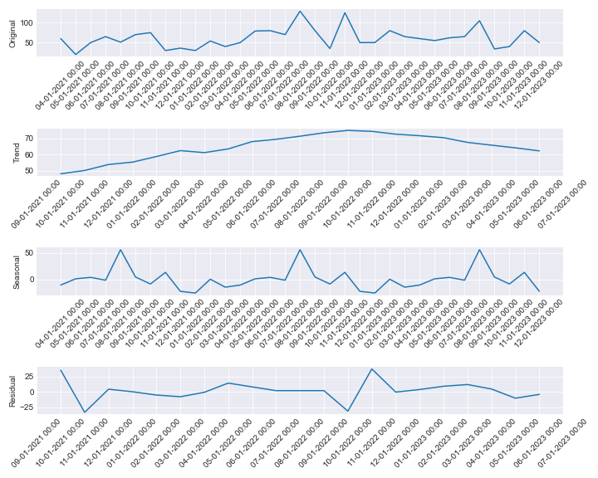

# Stationary tests for KIT0000203

ADF Test - p-value: 0.06901019851934224

ADF Test: Series is not stationary

KPSS Test - p-value: 0.1

KPSS Test: Series is stationary

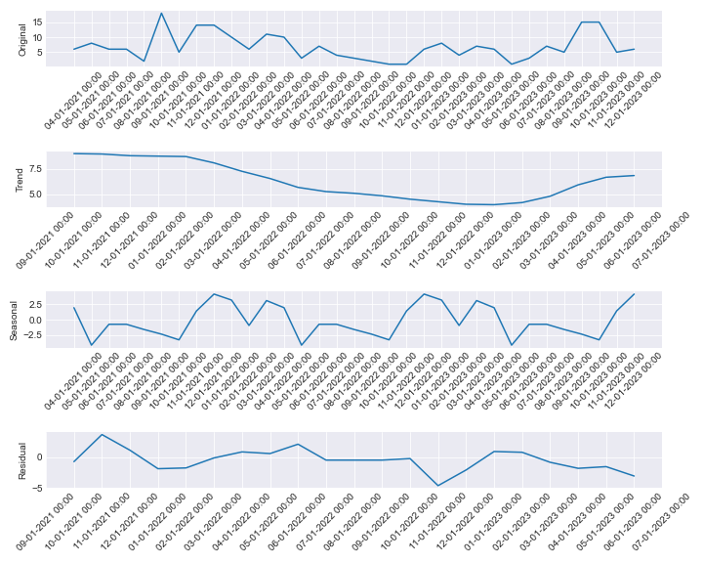

# Stationary tests for KIT0000204

ADF Test - p-value: 0.39129311497014163

ADF Test: Series is not stationary

KPSS Test - p-value: 0.0408659805327939

KPSS Test: Series is not stationary

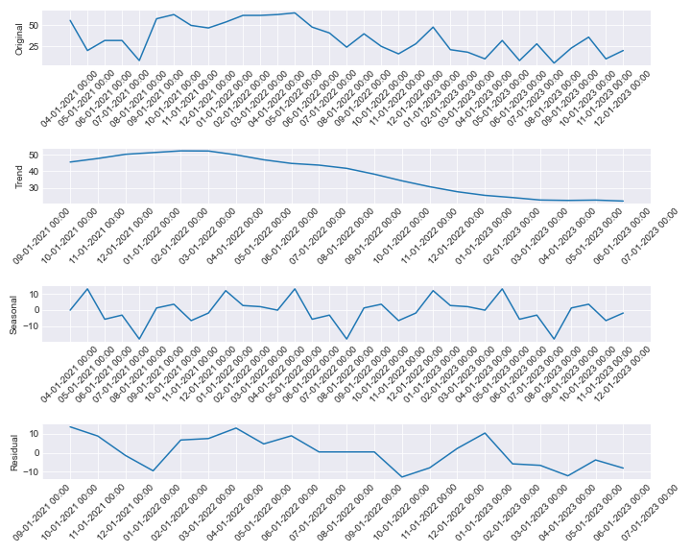

# Stationary tests for KIT0000460

ADF Test - p-value: 1.4881784253784808e-06

ADF Test: Series is stationary

KPSS Test - p-value: 0.1

KPSS Test: Series is stationary

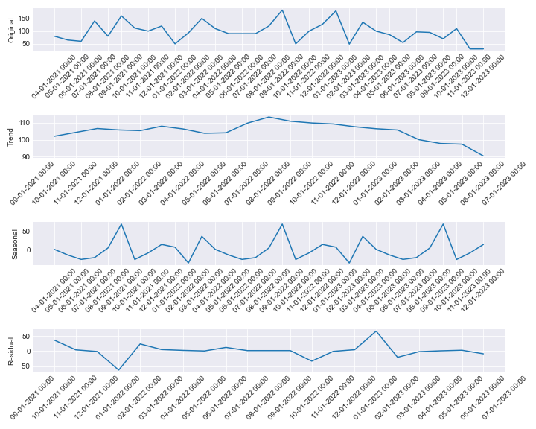

# Stationary tests for KIT0000461

ADF Test - p-value: 2.6780358832203733e-12

ADF Test: Series is stationary

KPSS Test - p-value: 0.1

KPSS Test: Series is stationary

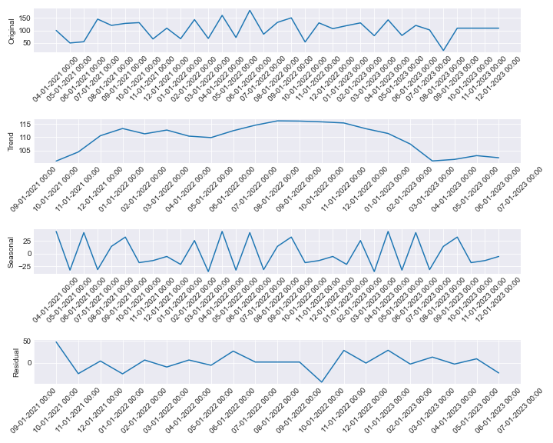

# Stationary tests for KIT0000959

ADF Test - p-value: 2.5771468640628562e-06

ADF Test: Series is stationary

KPSS Test - p-value: 0.1

KPSS Test: Series is stationary

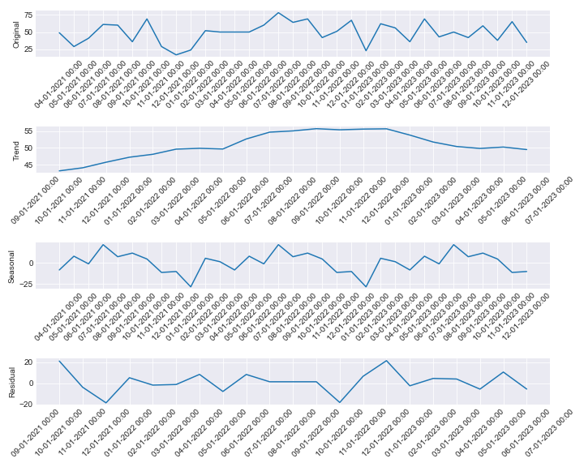

# Stationary tests for KIT0000560

ADF Test - p-value: 0.27107498505811545

ADF Test: Series is not stationary

KPSS Test - p-value: 0.04231897749383243

KPSS Test: Series is not stationary

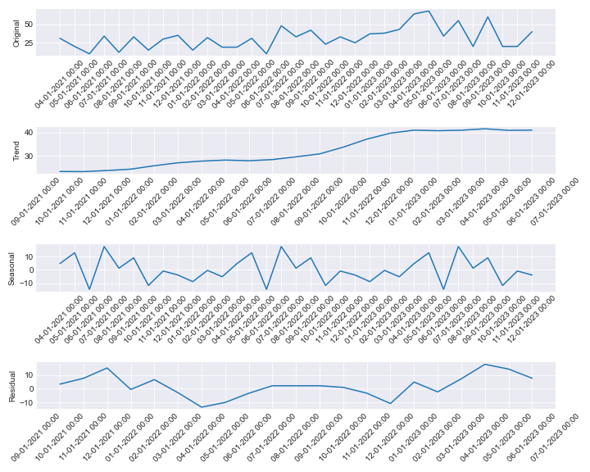

# Stationary tests for KIT0000990

ADF Test - p-value: 0.28901175718406885

ADF Test: Series is not stationary

KPSS Test - p-value: 0.03486229063087893

KPSS Test: Series is not stationary

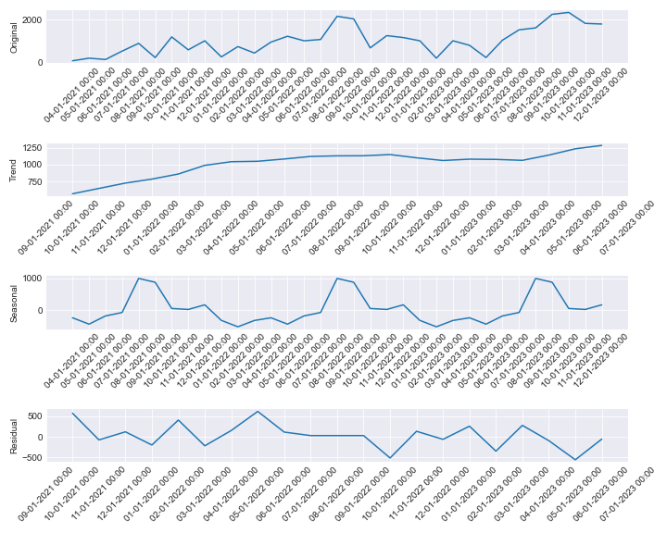

# Stationary tests for KIT0000526

ADF Test - p-value: 1.4247854033922721e-08

ADF Test: Series is stationary

KPSS Test - p-value: 0.1

KPSS Test: Series is stationary

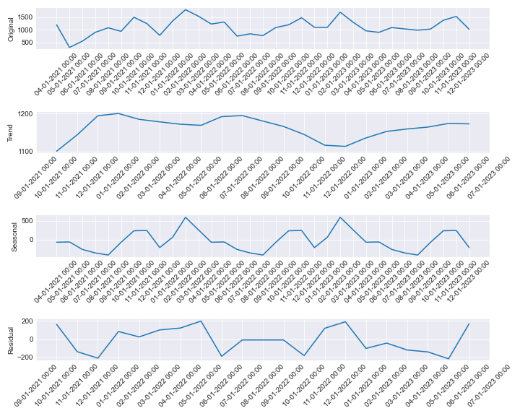

# Stationary tests for KIT0000294

ADF Test - p-value: 0.17350597839440235

ADF Test: Series is not stationary

KPSS Test - p-value: 0.08952696664035473

KPSS Test: Series is stationary

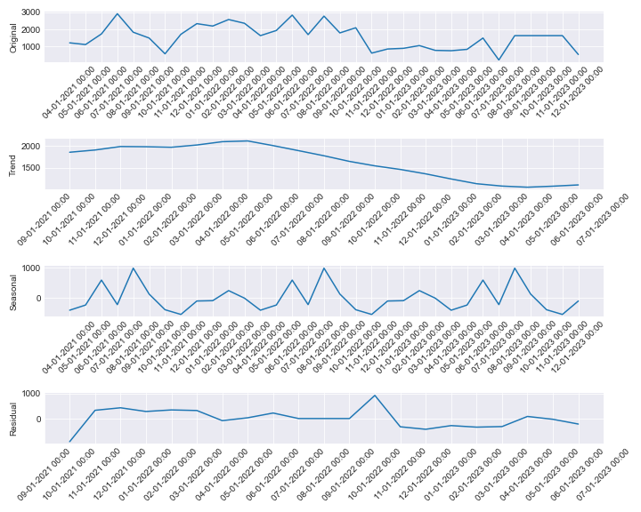

# Stationary tests for KIT0000414

ADF Test - p-value: 0.23423706968247388

ADF Test: Series is not stationary

KPSS Test - p-value: 0.06668936397351011

KPSS Test: Series is stationary

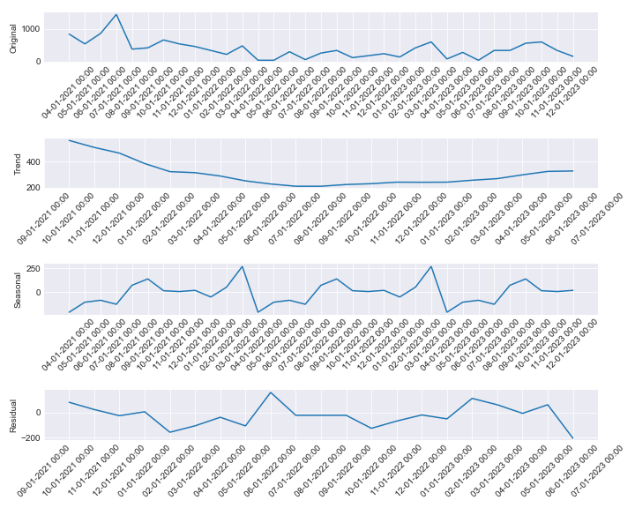

# Stationary tests for KIT0001037

ADF Test - p-value: 0.24531685578661266

ADF Test: Series is not stationary

KPSS Test - p-value: 0.1

KPSS Test: Series is stationary

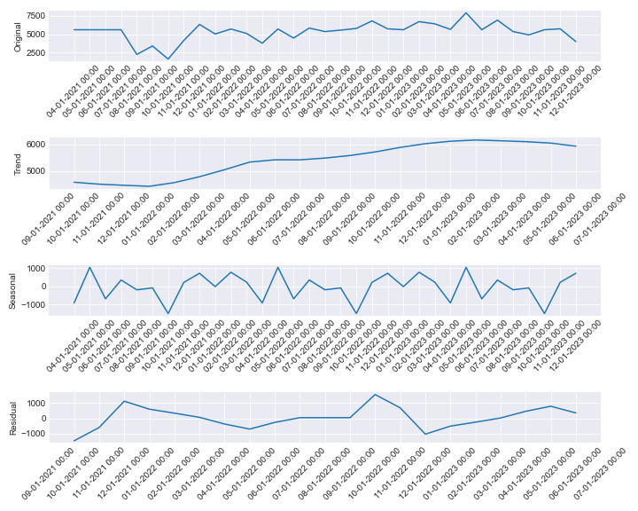

# Stationary tests for KIT0000084

ADF Test - p-value: 0.0013869303516086484

ADF Test: Series is stationary

KPSS Test - p-value: 0.1

KPSS Test: Series is stationary

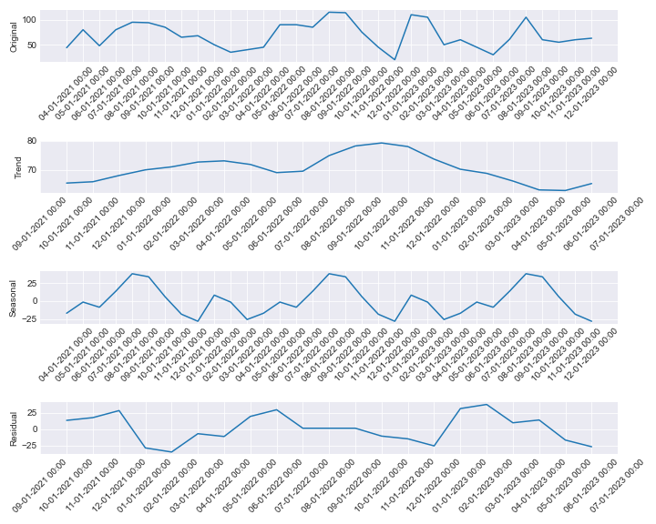

# Stationary tests for KIT0000174

ADF Test - p-value: 1.1232041673622505e-05

ADF Test: Series is stationary

KPSS Test - p-value: 0.1

KPSS Test: Series is stationary

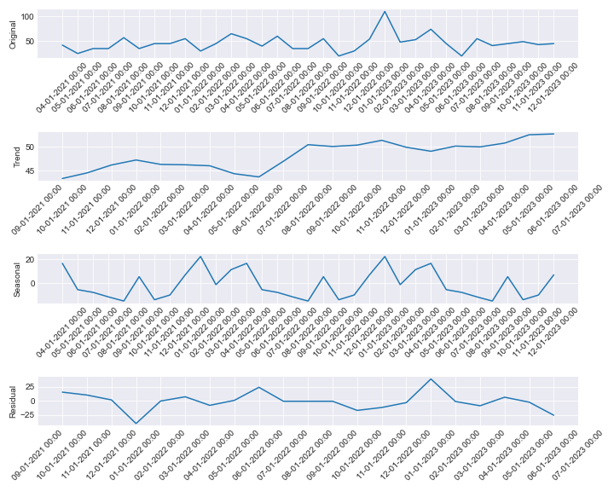

# Stationary tests for KIT0000175

ADF Test - p-value: 0.0023171094034033627

ADF Test: Series is stationary

KPSS Test - p-value: 0.1

KPSS Test: Series is stationary

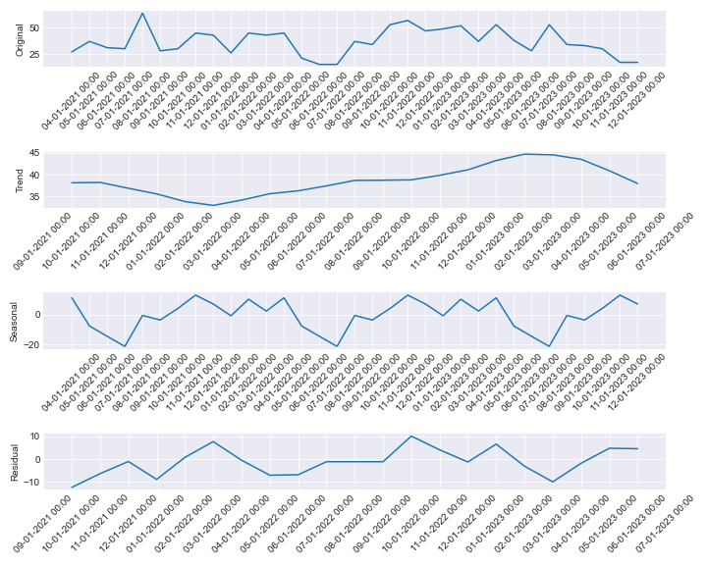

# Stationary tests for KIT0000227

ADF Test - p-value: 0.17312763717293345

ADF Test: Series is not stationary

KPSS Test - p-value: 0.042209738687196074

KPSS Test: Series is not stationary

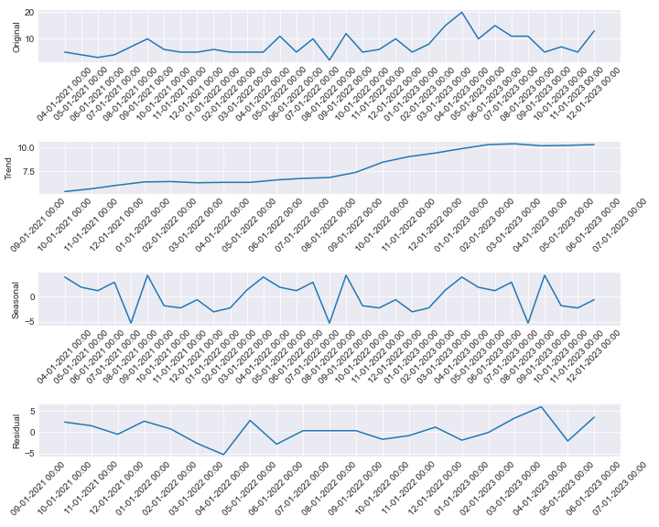

# Stationary tests for KIT0000228

ADF Test - p-value: 0.020333840033921115

ADF Test: Series is stationary

KPSS Test - p-value: 0.1

KPSS Test: Series is stationary

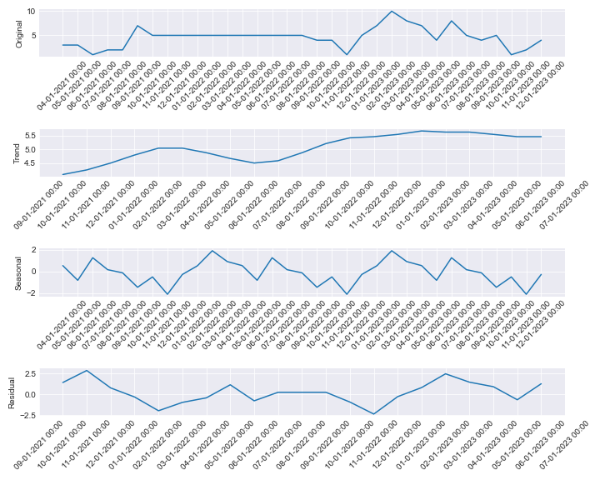

# Stationary tests for KIT0000353

ADF Test - p-value: 0.6045122981805969

ADF Test: Series is not stationary

KPSS Test - p-value: 0.011793560885207293

KPSS Test: Series is not stationary

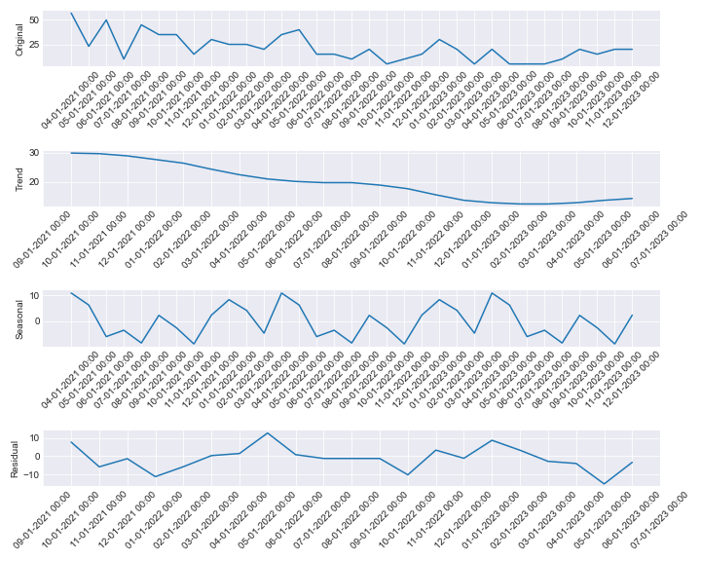

# Stationary tests for KIT0000784

ADF Test - p-value: 0.00034749795310916185

ADF Test: Series is stationary

KPSS Test - p-value: 0.034946526310090834

KPSS Test: Series is not stationary

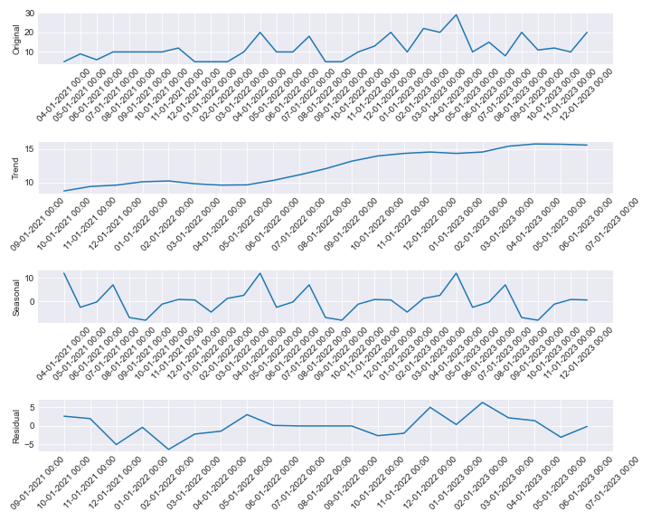

# Stationary tests for KIT0000016

ADF Test - p-value: 0.0063572701852652605

ADF Test: Series is stationary

KPSS Test - p-value: 0.09056248464883468

KPSS Test: Series is stationary

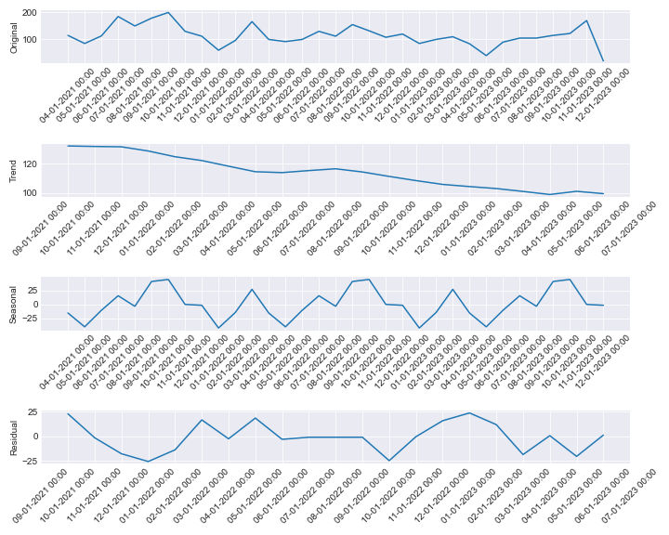

# Stationary tests for KIT0000123

ADF Test - p-value: 0.8506965795439346

ADF Test: Series is not stationary

KPSS Test - p-value: 0.01

KPSS Test: Series is not stationary

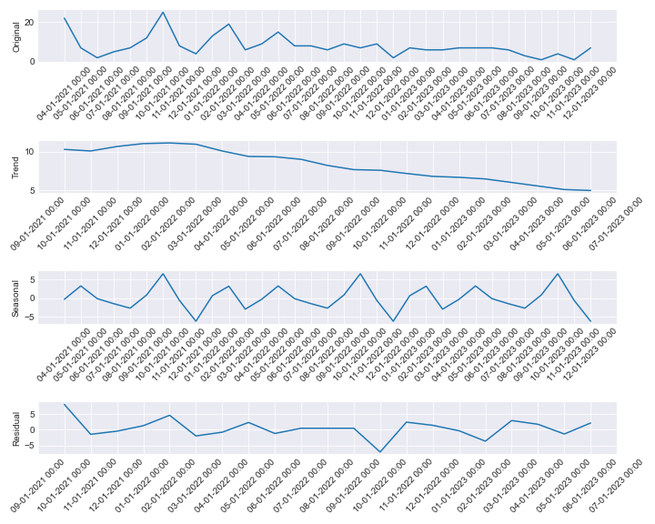

# Stationary tests for KIT0000147

ADF Test - p-value: 0.001993287049393131

ADF Test: Series is stationary

KPSS Test - p-value: 0.1

KPSS Test: Series is stationary

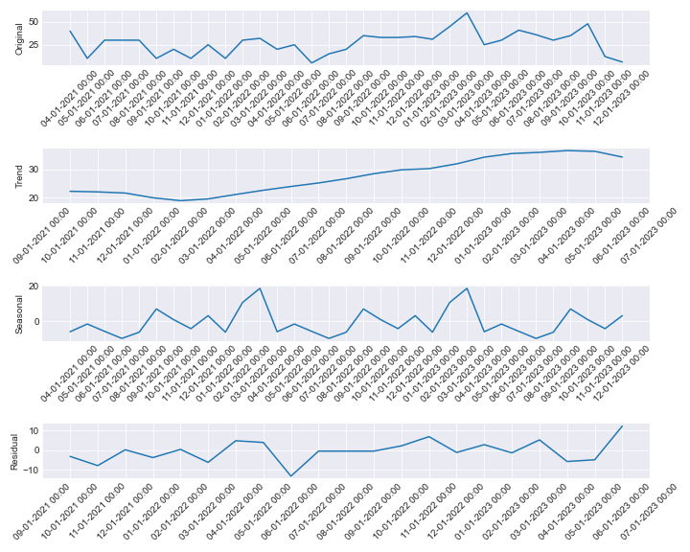

# Stationary tests for KIT0000177

ADF Test - p-value: 0.0001153454403588975

ADF Test: Series is stationary

KPSS Test - p-value: 0.1

KPSS Test: Series is stationary

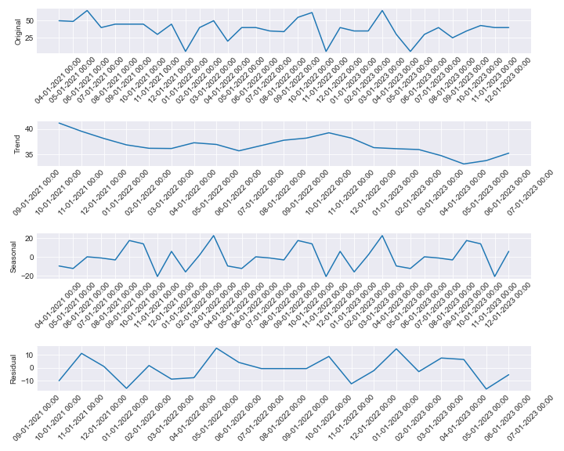

# Stationary tests for KIT0000256

ADF Test - p-value: 0.0011930270996699797

ADF Test: Series is stationary

KPSS Test - p-value: 0.1

KPSS Test: Series is stationary

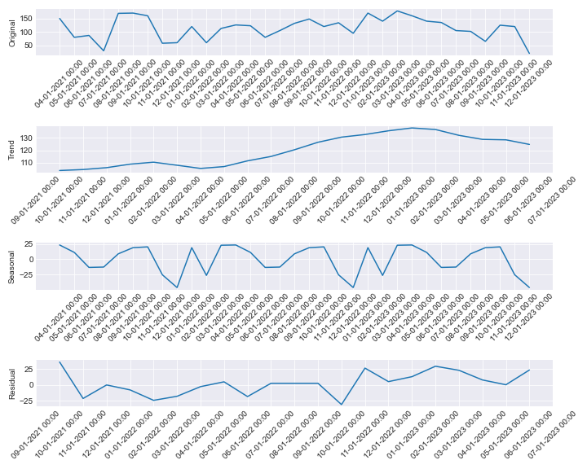

# Stationary tests for KIT0000298

ADF Test - p-value: 0.0010828768159530625

ADF Test: Series is stationary

KPSS Test - p-value: 0.04896945916160918

KPSS Test: Series is not stationary

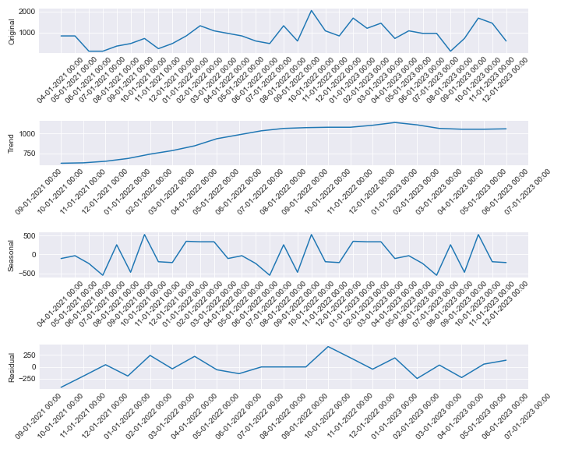

# Stationary tests for KIT0000942

ADF Test - p-value: 0.9962337629895247

ADF Test: Series is not stationary

KPSS Test - p-value: 0.01

KPSS Test: Series is not stationary

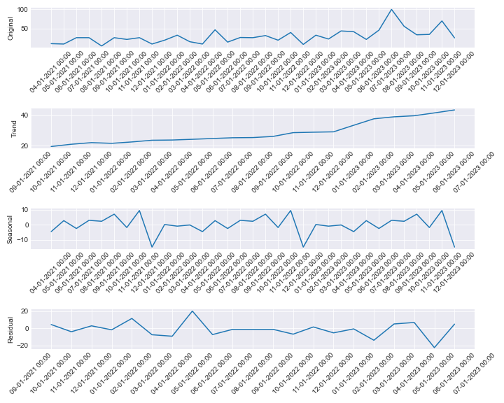

# Stationary tests for KIT0001002

ADF Test - p-value: 0.06464329043354722

ADF Test: Series is not stationary

KPSS Test - p-value: 0.1

KPSS Test: Series is stationary

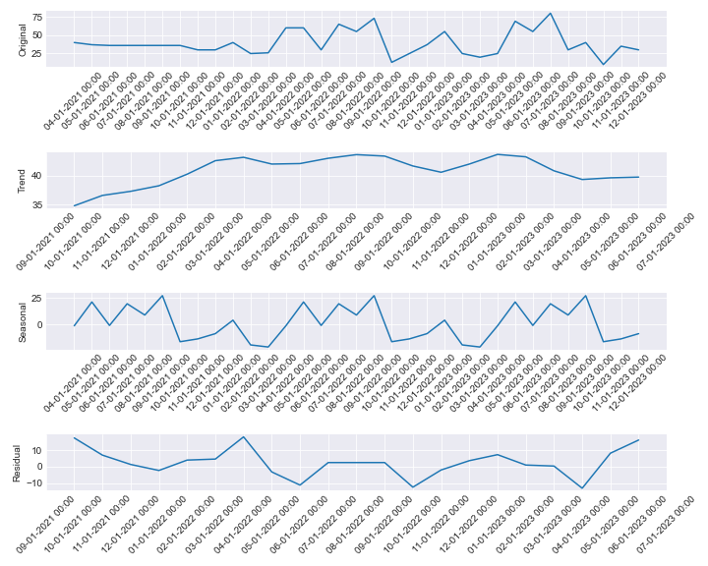

# Stationary tests for KIT0001004

ADF Test - p-value: 7.63070035062644e-05

ADF Test: Series is stationary

KPSS Test - p-value: 0.1

KPSS Test: Series is stationary

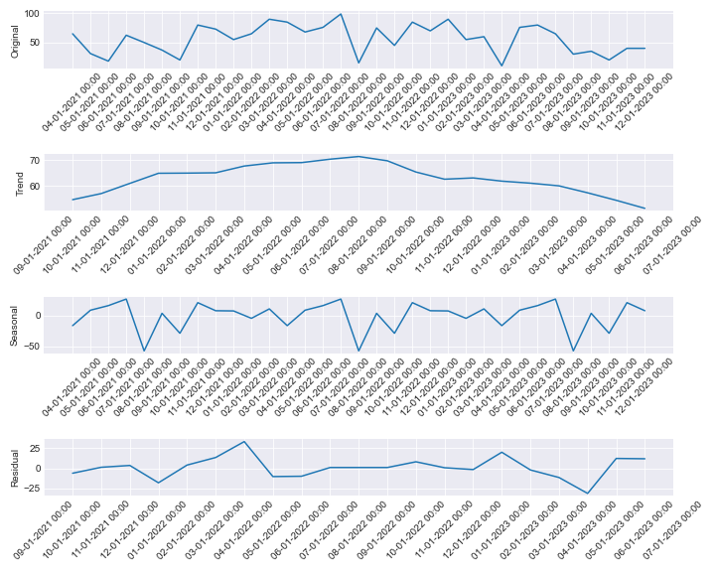

# Stationary tests for KIT0001008

ADF Test - p-value: 2.4095587156644237e-06

ADF Test: Series is stationary

KPSS Test - p-value: 0.1

KPSS Test: Series is stationary

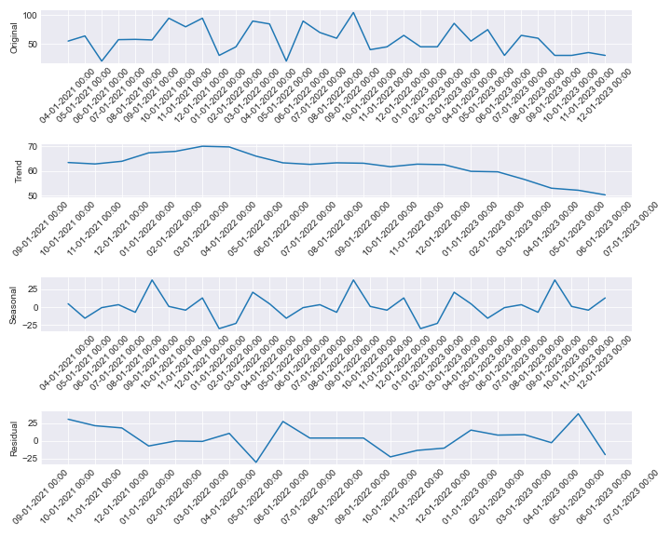

# Stationary tests for KIT0000162

ADF Test - p-value: 0.015163364213771931

ADF Test: Series is stationary

KPSS Test - p-value: 0.1

KPSS Test: Series is stationary

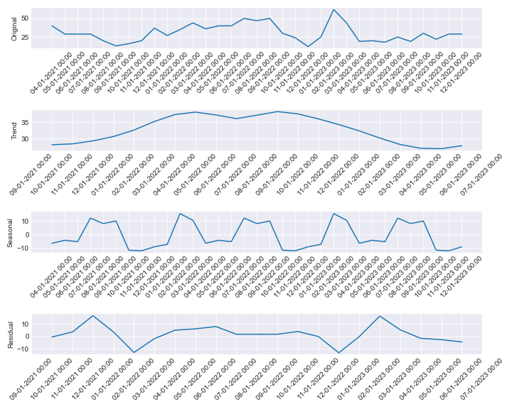

# Stationary tests for KIT0000201

ADF Test - p-value: 0.00042968273414089724

ADF Test: Series is stationary

KPSS Test - p-value: 0.07198680633875087

KPSS Test: Series is stationary

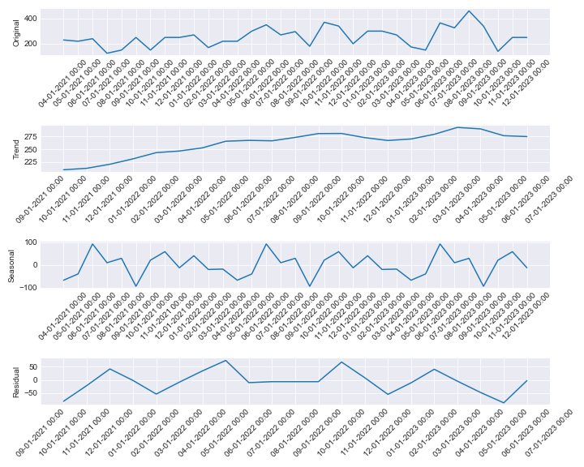

# Stationary tests for KIT0000884

ADF Test - p-value: 0.05085064313626354

ADF Test: Series is not stationary

KPSS Test - p-value: 0.09637092486953724

KPSS Test: Series is stationary

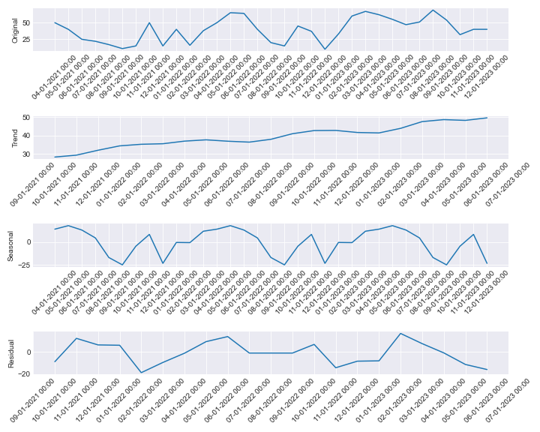

# Stationary tests for KIT0000268

ADF Test - p-value: 5.275174455976447e-05

ADF Test: Series is stationary

KPSS Test - p-value: 0.06741631159704042

KPSS Test: Series is stationary

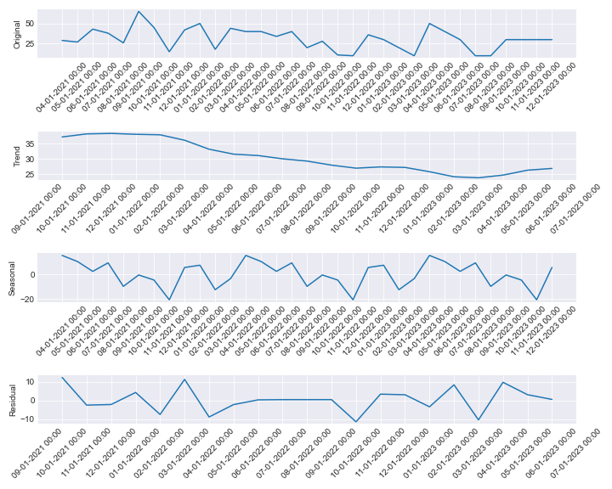

# Stationary tests for KIT0001000

ADF Test - p-value: 0.006899696152394297

ADF Test: Series is stationary

KPSS Test - p-value: 0.1

KPSS Test: Series is stationary

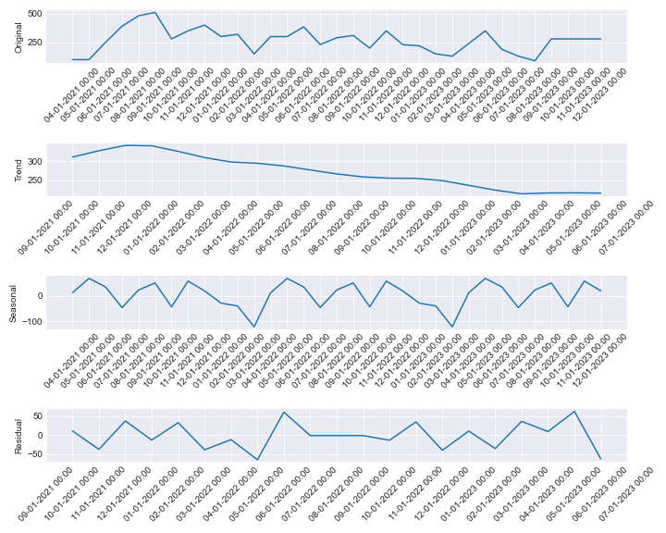

# Stationary tests for KIT0000885

ADF Test - p-value: 0.021559263991110945

ADF Test: Series is stationary

KPSS Test - p-value: 0.04053941221106562

KPSS Test: Series is not stationary

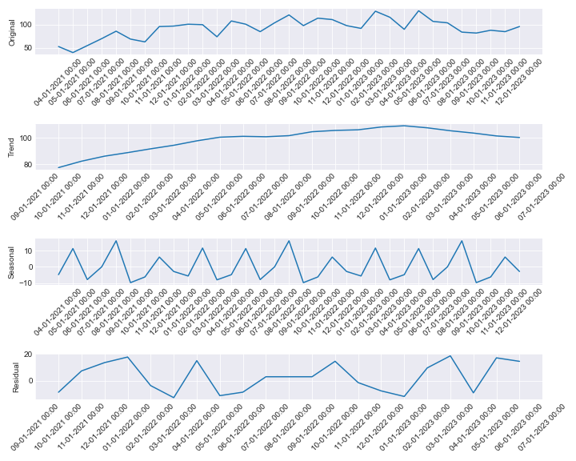

# Stationary tests for KIT0000886

ADF Test - p-value: 2.1340052431085304e-05

ADF Test: Series is stationary

KPSS Test - p-value: 0.029882180744456265

KPSS Test: Series is not stationary

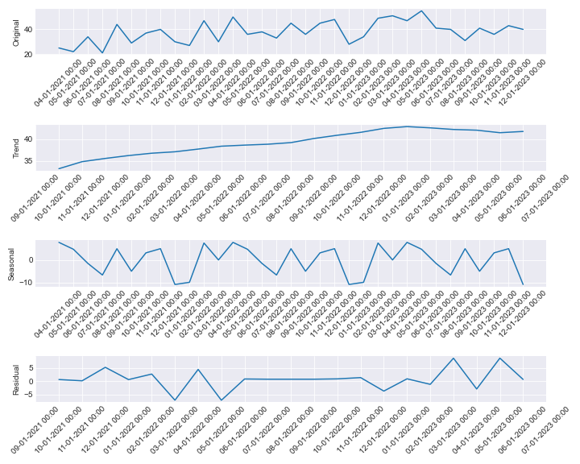

# Stationary tests for KIT0000887

ADF Test - p-value: 0.09578258627032754

ADF Test: Series is not stationary

KPSS Test - p-value: 0.09713192254479404

KPSS Test: Series is stationary

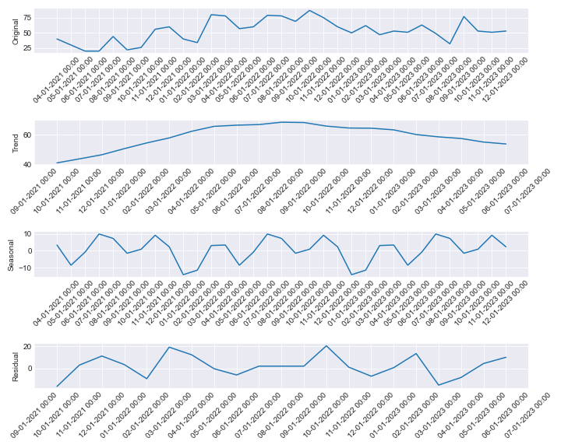

# Stationary tests for KIT0000888

ADF Test - p-value: 0.0011592670191741784

ADF Test: Series is stationary

KPSS Test - p-value: 0.03168678797693712

KPSS Test: Series is not stationary

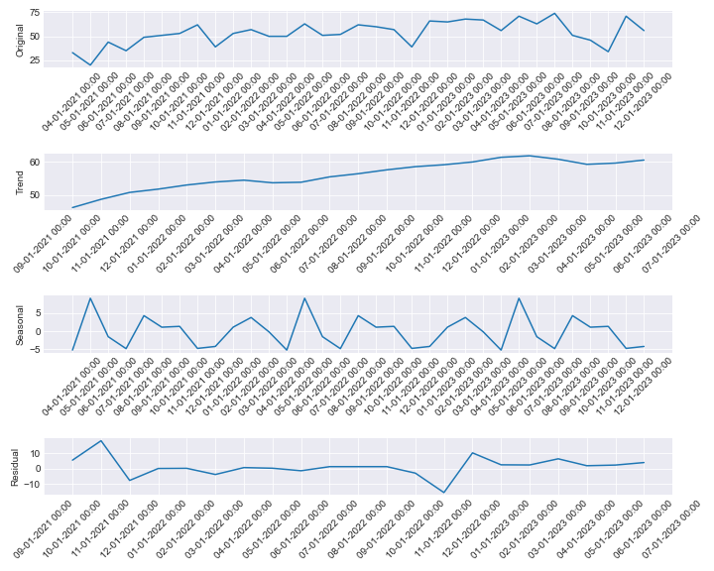

# Stationary tests for KIT0001025

ADF Test - p-value: 0.9268260212062619

ADF Test: Series is not stationary

KPSS Test - p-value: 0.01

KPSS Test: Series is not stationary

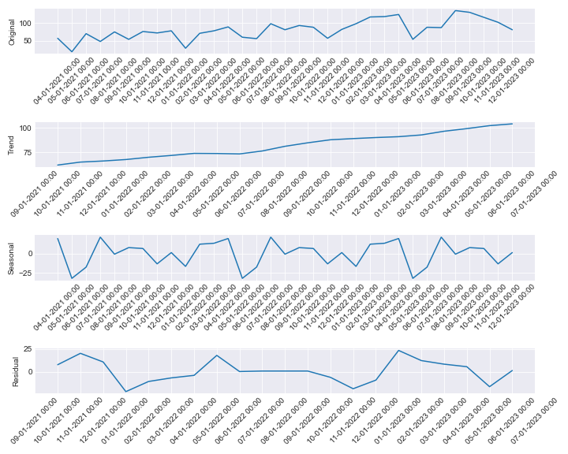

# Stationary tests for KIT0001026

ADF Test - p-value: 3.608754605608151e-08

ADF Test: Series is stationary

KPSS Test - p-value: 0.1

KPSS Test: Series is stationary

